
Documents

Replace with your figure or text (or leave blank)

User’s Manual
Release 1.0
December 20, 2007
Website: SimTK.org/home/dissemination

Copyright and Permission Notice

Portions copyright (c) 2007 Stanford University and <author(s)>.
Contributors: <whoever>

Permission is hereby granted, free of charge, to any person obtaining a copy of this document (the "Document"), to deal in the Document without restriction, including without limitation the rights to use, copy, modify, merge, publish, distribute, sublicense, and/or sell copies of the Document, and to permit persons to whom the Document is furnished to do so, subject to the following conditions:

This copyright and permission notice shall be included in all copies or substantial portions of the Document.

THE DOCUMENT IS PROVIDED "AS IS", WITHOUT WARRANTY OF ANY KIND, EXPRESS OR IMPLIED, INCLUDING BUT NOT LIMITED TO THE WARRANTIES OF MERCHANTABILITY, FITNESS FOR A PARTICULAR PURPOSE AND NONINFRINGEMENT. IN NO EVENT SHALL THE AUTHORS, CONTRIBUTORS OR COPYRIGHT HOLDERS BE LIABLE FOR ANY CLAIM, DAMAGES OR OTHER LIABILITY, WHETHER IN AN ACTION OF CONTRACT, TORT OR OTHERWISE, ARISING FROM, OUT OF OR IN CONNECTION WITH THE DOCUMENT OR THE USE OR OTHER DEALINGS IN THE DOCUMENT.

Acknowledgments

List your acknowledgements here, if desired. Example: SimTK software and all related activities are funded by the Simbios National Center for Biomedical Computing through the National Institutes of Health Roadmap for Medical Research, Grant U54 GM072970. Information on the National Centers can be found at http://nihroadmap.nih.gov/bioinformatics.

Table of Contents

1 Overview 1
2 Document Sections 3
2.1 Required Sections 4
2.2 Dividing Your Document into Sections 4
2.3 Cover Page 5
2.4 Copyright Notice 5
2.5 Acknowledgements 5
2.6 Table of Contents 6
2.6.1 Generating Content to Automatically Produce a Table of Contents 6
2.6.2 Modifying an Automatically Generated Table of Contents 9
2.7 List of Tables / List of Figures 10
2.7.1 Adding Captions to Tables and Figures 10
2.7.2 Modifying an Automatically Generated List of Tables Or List of Figures 11
2.8 List of Examples 12
2.9 Main Content 12
2.10 Other Sections 12
3 Other Recommendations 13
3.1 Formatting Details 13
3.2 Establishing a Formatting Convention for Instructions 15
3.3 Adding or Modifying Section Titles in Page Headers 15
3.3.1 Changing the Text for the Page Header 16
3.3.2 Changing the Formatting of Text in the Page Header 16
3.3.3 Automatically Adding Section Titles 17
3.4 Additional Notations to Assist the Reader 17
3.5 Formatting the First Page of a Chapter 18
Appendix A 21
Appendix B 23
References 25

List of Tables

Table 2-1. Document sections 3
Table 3-1. Suggested formatting details for a document 15

List of Figures

Figure 2-1. Dialog window for inserting breaks 4
Figure 2-2. The outlining toolbar is circled in red within the Microsoft Word document 7
Figure 2-3. Dialog window for modifying preset styles 8
Figure 2-4. Dialog window for modifying the format of the table of contents.. 9
Figure 2-5. The caption dialog window 10
Figure 2-6. Dialog window for creating a list of figures or list of tables. 11
Figure 3-1. The Field dialog window 16
Figure 3-2. Tab settings for page headers 17
Figure 3-3. Modifications needed to create a more sophisticated first page for a chapter 19
Figure 3-4. How to manually add chapter titles to page header 21

List of Examples

Overview

This document acts as both a template and a manual for any documentation related to SimTK software, such as user manuals, descriptions of application programming interfaces (APIs), and tutorials. Most of the conventions used in this template are stylistic choices, which you can modify as desired. There are a few aspects of the document, such as the cover page, that we respectfully request that you do not change. These are described in Chapter 2, which provides details about the different sections of the document template.

Chapter 3 lists other suggestions, including the stylistic settings for this template, which you may want to incorporate into your document.

All instructions (menu selections, commands to type, etc.) will be indicated in dark-blue, bold text. Names of dialog windows and other text in windows used by Microsoft Word will be italicized.

This document is an updated version of the one originally written by David Delp and Paul Mitiguy. If you have any questions, suggestions, or comments, please contact Joy Ku (joyku@stanford.edu).

Document Sections

The sections that make up this template are listed in Table 2-1 below. Each section is marked within the template as an actual Microsoft Word section. Each chapter within the main content typically will also be set up as its own individual section.

Section | Requirement
Cover Page | Required
Copyright | Highly recommended
Acknowledgements | Optional
Table of Contents | Highly recommended
List of Tables | Optional
List of Figures | Optional
List of Examples | Optional
Main Content | Required
Appendices | Optional
References | Optional
Table 2-1. Document sections
You can see where these sections are by switching to a normal view (select: View → Normal). This template is set up assuming the document is double-sided, so you will see that the sections start on an odd page, as indicated by the notation Section Break (Odd Page).

Required Sections

Please include the required sections listed in Table 2-1 in your document: the cover page and the main content.

Dividing Your Document into Sections

Section breaks can be used to get different formatting in different parts of your document. To insert a break, select: Insert → Break. The dialog window shown in Figure 2-1 below will appear. Select the appropriate option under Section break types: Next page, Continuous, Even page, Odd page. Then, click OK.

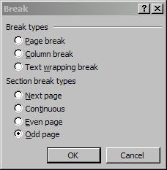
Figure 2-1. Dialog window for inserting breaks

For example, since this document is double-sided, you would select Odd page to start a new section in this document.

Cover Page

The first page of this document is the template for the cover page for SimTK documentation. Please use it for cover pages for all end-user documentation, e.g., API guides, user manuals, and tutorials.
Please do not change the cover page’s font size, font family, etc. And please do not change the characteristics of the embedded “Cover” styles. You are encouraged to replace the figure for your scientific application (or request assistance for another graphic).

You should also update the text to reflect your specific purpose. Typically, the top line next to the SimTK logo is used for the application or project name, e.g., Simbody. At the bottom of the cover page, you will specify the type of documentation this is, e.g., User’s Manual, Developer’s Guide. You also need to modify the release number, the release date, and the website URL for your document.

Copyright Notice

Though not required, it is highly recommended that you include a copyright page. This will appear on the inside front cover of the document and is the first page of what is called the “front matter.”

The copyright and permission notice used in this template can be modified to suit your purposes. Whether you change the notice or not, be sure to update the copyright year and author list.

Acknowledgements

This is an optional section that you can use to recognize those who have assisted you, provided funding, etc.

Table of Contents

The table of contents is a useful guide for your reader, so it is highly recommended that you include one in your document, particularly if your document is lengthy.

The table of contents can be generated manually or automatically within Microsoft Word. This template is set up to automatically produce a table of contents, but it requires following certain conventions when creating your document, described in Section 2.6.1 below. The formatting of the automatically generated table of contents can be modified. Details for reformatting are given in Section 2.6.2.

Generating Content to Automatically Produce a Table of Contents

This template uses an outline format that is tied to specific heading styles to automatically generate a table of contents. The table of contents will show any text associated with outline levels 1 to 3 (which are tied to headings 1 to 3). You can modify which levels are included in the table of contents—see Section 2.6.2.

Outline Levels

The outline format in Microsoft Word produces the automatic numbering you see here, delineating the different parts of the document. This particular part discussing outline levels is numbered 2.6.1.1 and corresponds to level 4 in the outline. The text within this section is labeled body text and is not numbered.

As mentioned earlier, the template default produces a table of contents that includes outline levels 1 to 3. For instance, the text “Outline Levels” is level 4 in the outline format and would not appear in the table of contents. Also, notice that this document’s table of contents lists “Appendix A” but not the “List of Tables,” though both titles (see pages vii and 28) look the same. This is because the text for “Appendix A” on page 28 is labeled as a level 1, but the “List of Tables” text is labeled as body text and then reformatted to a larger font size.

Viewing Outline Levels

You can view the outline level for different parts of the document by displaying the Outline toolbar (select View → Toolbars → Outlining). A short bar showing 4 sets of arrows and a pull-down menu should appear (See Figure 2-2).

The text in the pull-down menu will indicate the outline level associated with the cursor position. For example, if you move the cursor to the end of this sentence, body text will show up in the text box associated with the pull-down menu. If you move the cursor to the header “2.6.1.1 Outline Levels,” Level 4 will appear in the text box.

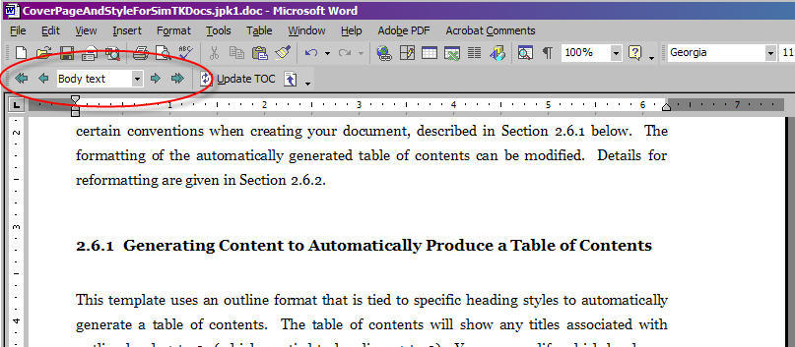
Figure 2-2. The outlining toolbar is circled in red within the Microsoft Word document

Setting the Outline Level

You will also use the Outline toolbar to set the outline level for the text that you enter. To assign an outline level to text, enter the text. Place the cursor in the middle of the text, and then use the arrow buttons on the Outline toolbar to assign the text to the appropriate outline level.

Modifying the Format of an Outline Level

The format associated with a particular level is determined by heading styles: Level 1’s format is determined by Heading 1; Level 2’s format is determined by Heading 2; Level 3’s format is determined by Heading 3, etc.

You can view the formatting options of a heading by opening up the window for Styles and Formatting (select: Format → Styles and Formatting). The styles are listed in alphabetical order. Scroll through the list until you reach the ones for Heading 1 through Heading 9.

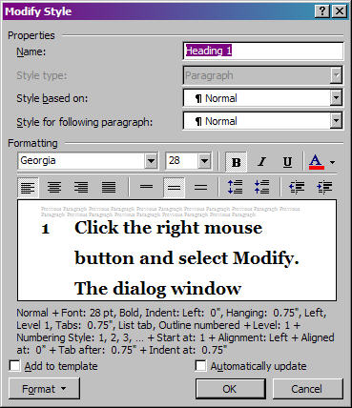
Figure 2-3. Dialog window for modifying preset styles

Move the cursor to Heading 1. Click the right mouse button and select Modify. The dialog window shown in Figure 2-3 above will appear and can be used to alter the font, the numbering, the tabbing, and many other stylistic choices.

Modifying an Automatically Generated Table of Contents

To update the text shown in the table of contents, place the cursor in the middle of the table of contents. Click the right mouse button and select Update Field. You can choose whether to update just the page numbers or the entire table. If you have added new sections that you want to appear in the table of contents, you should update the entire table.

To alter the format of the table of contents, place the cursor at the beginning of the first entry in the table of contents. Select: Insert → Reference → Index and Tables. The dialog window shown in Figure 2-4 below will appear.

In the Index and Tables window, click on the tab for Table of Contents. You can change the number of outline levels to be included in the table of contents by altering the entry for Show levels (circled in red). You can also modify the formatting of the text for each heading by clicking on the Modify button.

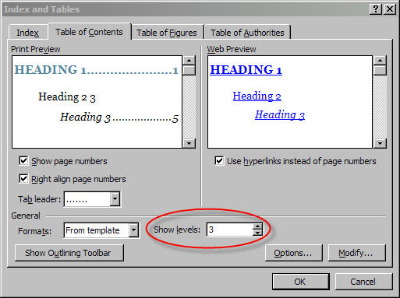
Figure 2-4. Dialog window for modifying the format of the table of contents. The number of outline levels that are displayed in the table of contents is determined by the entry for Show levels (circled in red).

List of Tables / List of Figures

The list of tables and the list of figures are optional. Just as with the table of contents, they can be generated automatically within Microsoft Word. However, you have to create the captions using the tools provided within Word, as opposed to just adding text next to your table or figure.

Adding Captions to Tables and Figures

To add a caption using the Microsoft Word tool, right click on the table or figure to which you want to add a caption. Select Caption from the menu that appears.

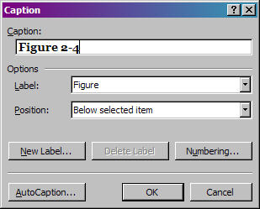
Figure 2-5. The caption dialog window

A Caption dialog window appears (Figure 2-5). Choose the appropriate label (figure or table) from the menu for Label and enter the caption in the text box for Caption. You can click the button labeled Numbering… to alter the numbering scheme. The format used for this template is to display the chapter number (based on Heading 1) and the figure/table number, separated by a hyphen.

Modifying an Automatically Generated List of Tables Or List of Figures

The list of tables and list of figures are modified and created similar to the table of contents.

To update the text shown in the list, place the cursor in the middle of the list. Click the right mouse button and select Update Field. You can choose whether to update just the page numbers or the entire table (list). If you have added new sections that you want to appear in the list, you should update the entire table.

To alter the format of the list, place the cursor at the beginning of the first entry in the table of contents. Select Insert → Reference → Index and Tables. A dialog window will appear. Select the tab for Table of Figures (See Figure 2-6). The selection for the Caption label (circled in red in Figure 2-6) determines whether you are creating and modifying a list of figures or tables.

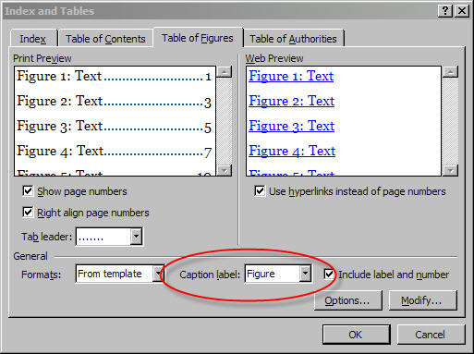
Figure 2-6. Dialog window for creating a list of figures or list of tables. The Caption label (circled in red) determines whether a list of figures or a list of tables is created.

Microsoft provides several default formats, which can be selected from the menu for Formats. You can also click on the Modify button to bring up a new window that allows you to change the detailed formatting (e.g., font) for the list.

The full caption for the figure or table is always displayed. However, you can omit the figure/table number by unchecking the box for Include label and number.

List of Examples

The list of examples tells the reader where example code is located within the manual. It could also be used to guide readers to detailed examples of how to accomplish a task within an application. This list is optional and would need to be generated manually.

Main Content

The content is the heart of the document. It is recommended that some numbering scheme, such as the outline format used in this template, be established to organize the content and guide the user through the document.

Other Sections

Other sections that you may want to include in your document include appendices and references, which would appear at the end of the document after the main content.

chapter
3

Other Recommendations

This chapter provides the formatting details used in this template and also discusses some other ideas that can make your document easier to use.

Formatting Details

Table 3-2 below lists the format used for this template.

Justification | Justify the text when using the full width of the page. Align left (ragged right) when using narrow columns.
Font | Main body: Georgia 11 pt. The Normal style should apply this feature.  Source Code: Courier New 11 pt. or smaller.
Line space | Use 1.5 line spacing in main body of text.  Use 1.5 or smaller line spacing in figure descriptions and footnotes.  Use 1.5 or smaller line spacing in table of contents and index.
Margins | Set your Microsoft Word document for double-sided printing and binding. Select File -> Page Setup and under Margins, select Mirror Margins in the Multiple Pages.  Minimum margins of 1.25” inside margins and 1.0” outside margins so the text does not run into the binding and so it can be printed with 8.5” x 11” paper or A4 paper 8.27” x 11.69”.  If a line is used in the header, additional spacing will be needed at the top so a minimum margin of 1.25” is recommended.  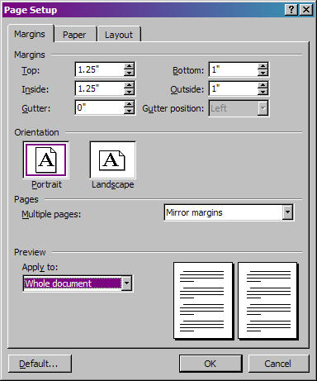
Page Numbers | Front Cover page: None  Back Cover page: None  Inside Covers: None  Front matter: Roman numbering  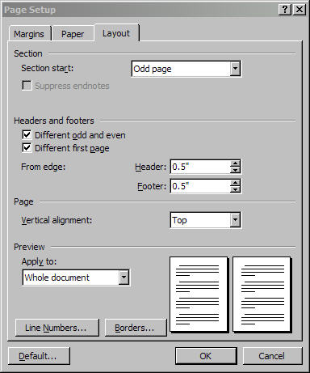  Main matter: Arabic numbering with page numbers in upper-right of right pages and upper-left of left pages. Exception: the first page of a section will be numbered in the lower-right of right pages and lower-left of left pages.
Table of contents | Appears in front matter (page numbers with roman numerals)
Footnotes | Appear on the bottom of the page on which they appear
Appendixes | Appear at the end of the manuscript
References | Appear at the end of the manuscript in alphabetically order.  Choose a consistent style for book, papers, and other citations.
Figures | Appear as close as possible to the associated text (right, left, above, below)
Table 3-2. Suggested formatting details for a document

Establishing a Formatting Convention for Instructions

To help the reader use your document, it is recommended that you establish a convention for the instructions (e.g., menu selections, API function calls) that will be provided and tell your reader early on what that convention is.

For example, in this document all menu selections and commands are shown in a dark-blue, bold text. Names of windows and labels used within Microsoft Word are italicized.

Adding or Modifying Section Titles in Page Headers

Displaying section titles at the top of the pages is another way to help readers navigate through your document.

The style used in this template displays the chapter name (level 1 outline level) at the top of the left-hand pages and the level 2 outline title at the top of the right-hand pages. This text is generated automatically using Microsoft Word except in cases where the first page of a chapter has special formatting (See Section 3.5).

When multiple level 2 sections appear on a page, the first level 2 title to occur is displayed. If no level 2 section titles appear on the page, Microsoft Word will search from the top of the given page backwards to the beginning of the document, until it encounters a level 2 title, which will then be used in the header.

Changing the Text for the Page Header

To change the outline level that appears in the header, select View → Header and Footer. Right click on the title (not the page number) and select Edit Field. The Field dialog window, shown in Figure 3-7, will appear. You can select which section title appears in the page header by changing the Style name to a different Heading. Remember that this template assigns Heading 1 to Level 1 of the outline format, Heading 2 to Level 2 of the outline format, etc. So, if you want to display the titles for outline level 4 in the page header, you would set the Style name to Heading 4.

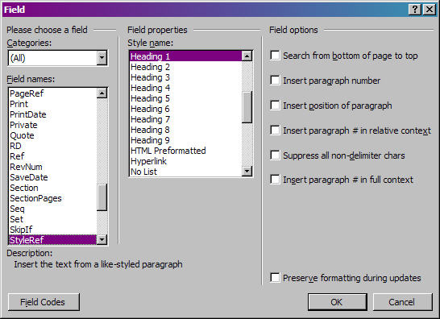
Figure 3-7. The Field dialog window

Changing the Formatting of Text in the Page Header

To change the font of the title in the header, select View → Header and Footer. Highlight the text you want to alter and then right click on the text. Select Font... to bring up the standard Font dialog window to alter the font associated with the title.

The placement of the titles within the header is determined by tabs. Within this template, the titles begin 0.25” from the left-hand margin for the even pages. On the odd pages, the titles end 0.25” from the right-hand margin UNLESS the title is too long. The maximum length of the title is determined by the left-hand tab (indicated by the red arrow in Figure 3-8) and the right-hand tab. For this template, the maximum length is 4.75.” Text that is longer than 4.75” will extend beyond the right margin.

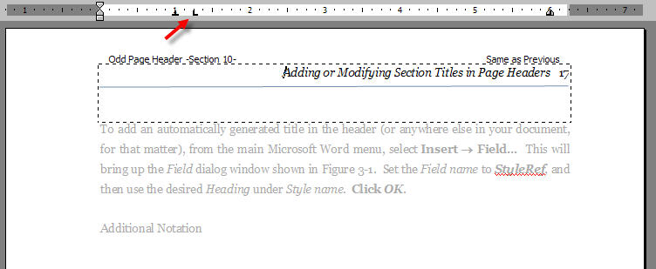
Figure 3-8. Tab settings for page headers

Automatically Adding Section Titles

To add an automatically generated title in the header (or anywhere else in your document, for that matter), from the main Microsoft Word menu, select Insert → Field… This will bring up the Field dialog window shown in Figure 3-7. Set the Field name to StyleRef, and then use the desired Heading under Style name. Click OK.

Additional Notations to Assist the Reader

It can be helpful to provide sidebars and/or special icons to alert readers to important points in the document.


For example, the icon shown to the left could be inserted to highlight warnings or common errors that readers make when performing a task. Or it could be used to indicate an important point. The key is to let the reader know at the beginning of the document what the icons mean.
Sidebar
Example
This is one example of how a sidebar could be created. It is a table consisting of two rows. The first row is split into two columns: one for the icon and one for the title of the sidebar. The second row contains the text for the sidebar.

Background shading is used for the table to help it stand out from the rest of the text. This color can be modified by right-clicking on the table and selecting Borders and Shading... From the dialog window that appears, select the tab for Shading. Choose the desired color.

ALTERNATIVE: Other ways of achieving a similar effect are to change the font, as shown here, and/or to use sidebars.

The sidebar could be useful for highlighting important points for the reader. Another potential use is for code snippets and examples. Again, the key is to tell the reader at the beginning of your document what conventions are being used.

Formatting the First Page of a Chapter

You may have noticed that the first pages of Chapters 1 and 2 look differently than that of Chapter 3. Both options are presented here because of trade-offs regarding the looks versus functionality and maintainability.

While the first page of Chapter 3 is more distinctive and will let the reader know more immediately that he/she has reached the beginning of a new chapter, it requires more manipulation if Microsoft Word’s automated features using headings are to be used. Creating the first page of Chapter 1 or 2 is very straightforward: just enter the chapter title and set the outline level for the title to level 1.

To use automatic numbering with the format for the first page of Chapter 3, you need to:

- Type in the chapter title and set the outline level for the title to level 1.

- Remove the number associated with the chapter title. Example: The default level 1 format will look like this:
1 Chapter Title
Remove the “1” from the title. This avoids repetition, since the icon in the upper-right of the page already indicates the chapter number. However, it means that Microsoft Word no longer has a level 1 number to associate with this section. All tables, figures, and subsequent headers in this chapter will be numbered incorrectly.

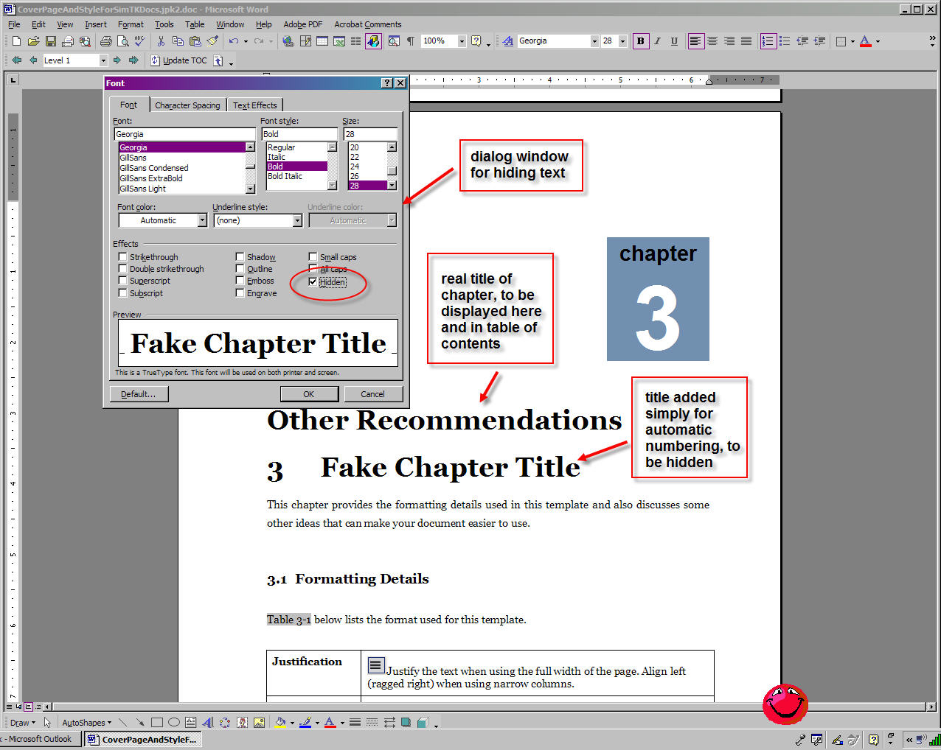
Figure 3-9. Modifications needed to create a more sophisticated first page for a chapter

This title (without a leading number) is what appears in the table of contents. If you wish to have the chapters numbered in the table of contents, you will need to manually add the numbers.

3. To prevent incorrect number of tables, figures, and headers in this chapter, you need to add in another level 1 text line but make it hidden. So repeat step 1. Then, highlight the text and select Format → Font… to bring up the Font dialog window. Check the box next to the option Hidden (See Figure 3-9).

The challenge is not to accidentally delete the hidden text, which would change the automatic numbering.

Since the level 1 text is now hidden, it does not appear in the page header either. So if you want to have level 1 chapter titles appear on the left-hand pages, as done in this document, you need to do this manually.

- Select View → Header and Footer.

- Scroll to the first even page of the chapter. You should see something similar to what is shown in Figure 3-10.

- If the header is set to be the same as the previous pages’ headers, then unselect that option by clicking the two-page icon in the Header and Footer menu. To determine the header setting, look in the upper-right corner of the header. If the words “Same as Previous” appear, then the header is set to be the same as the previous pages’ headers.

- Manually enter the chapter title into the header.

- This process will need to be repeated for each chapter.

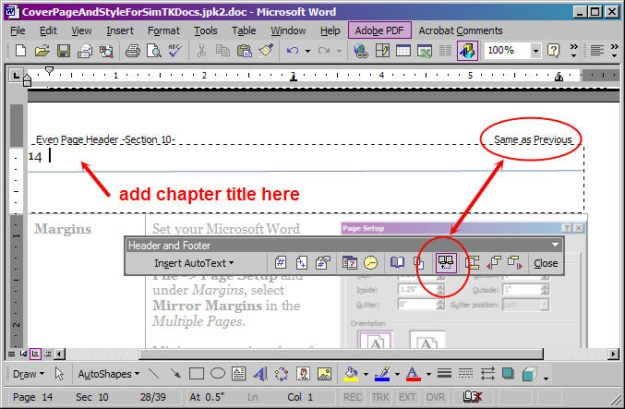
Figure 3-10. How to manually add chapter titles to page header. 1) From the menu, select View → Header and Footer. 2) Scroll to the first even page of the chapter. 3) Make sure the header is NOT set to “Same as Previous.” 4) Manually enter the chapter title in the left-hand corner next to the page number, or wherever desired.

Appendix A

Appendix B

References

