BioE215 – New Course Announcement
Physics-based Simulation of Biological Structures

Sponsored by BioEngineering and Simbios: The NIH Center for Biomedical Computation at Stanford

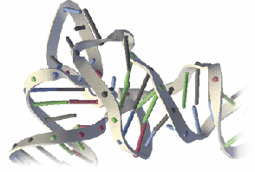
Prerequisites: C (or C⁺⁺) programming skills.
Basic knowledge of biology, chemistry, mathematics, and physics (F=ma)
Experience with ordinary differential equations is helpful.

Enrollment: Limited enrollment

Time/Units: Class meets Wednesday/Friday 11:00-12:15 in Clark E305. 3 Units.

Projects Simulation labs (60%). Simulation Project (40%).

Instructors Paul Mitiguy, Russ Altman, Scott Delp

Website: www.simtk.org/home/training

Info:

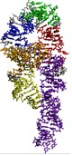
Course Objectives
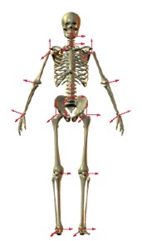
- Model, analyze, and interpret the mechanics (F=ma) of biological systems (physical insights)
- Identify important parameters for physics-based modeling of biological structures
- Simulate biological structures with professional computational tools
- Ability to design and conduct computer experiments and analyze simulation results
- Develop a hands-on, minds-on, can-do attitude

Labs

- Getting started with SimTK Hello Math!
- Getting started with Simbody Introduction to physics-based simulation
- Biomechanical/Molecular Modeling and Geometry Mass, mass center, and inertia
- Biomechanical/Molecular Modeling and Forces Forces, torques, muscles, and intermolecular attraction
- Biomechanical/Molecular Modeling and Motion Mobilizers, joints, and constraints. Configuration and motion
- Biomechanical/Molecular simulations Biology, Chemistry, Math, Physics (F=ma), and computation
- MIPSI Lab Self-selected project

 NIH Roadmap grant U54 GM072970

