BioE215 Physics-based Simulation of Biological Structures
Equations for Modeling the Forces Generated by Muscles and Tendons
Clay Anderson, May 11, 2007

This purpose of this document is to provide relatively simple, concrete examples of how force generation by muscle and tendon can be modeled. Equations for five lumped-parameter models of increasing complexity are developed below. This first page defines the symbols used in the equations.

Definitions
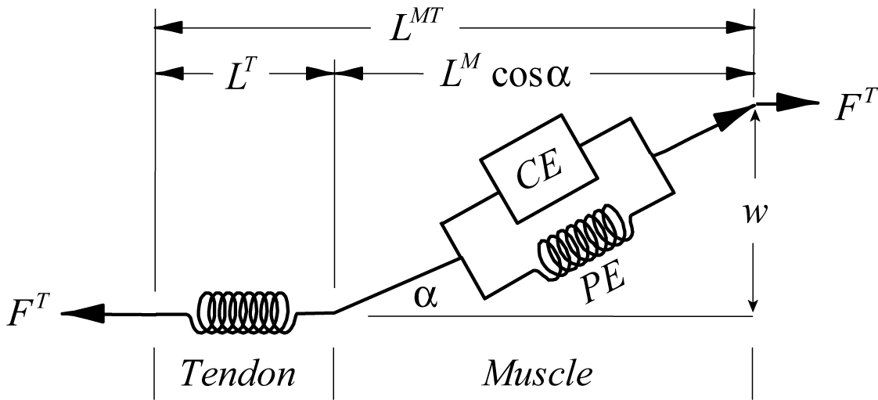
= Tendon
= Muscle
= Contractile Element
= Parallel Elastic Element

= Length
= Velocity
= Force
= Area

= Elasticity Modulus (stress / strain)
= Stress (force / area)
= Strain (% change in length)

= Muscle activation. Variable used to quantify the concentration of calcium Ca++ in the lumen of the fibers of a muscle.
a=1.0 means full activation; a=0.0 means no activation
= Muscle excitation
Muscle excitation is a variable used to quantify the net motor signal to a muscle.
x=1.0 means full excitation; x=0.0 means no excitation
= Pennation angle. Angle between the line of action of a muscle’s fibers and the line of action of its tendon.

= Tendon slack length. The length at which tendon begins to generate force.
= Optimal muscle fiber length. Fiber length at which muscle generates its largest force.
= Maximum shortening velocity of muscle, normalized by optimal fiber length ().
= Optimal muscle force. Force generated by muscle when its fibers are at .
= Optimal pennation angle. Pennation angle when a muscle’s fibers are at .
= Width of muscle.
= Optimal tendon stress. Stress developed by tendon when the force is .
Overview of Models

Parallel Fibered Pennate

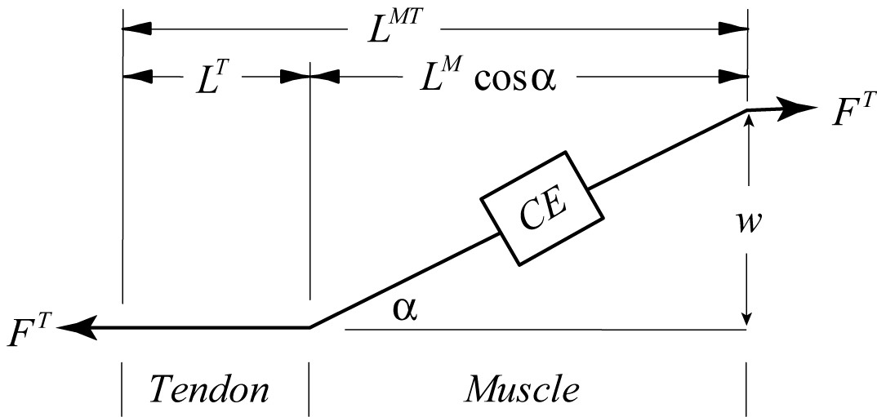

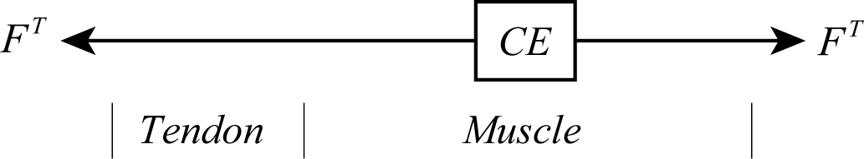

1a) Simples possible
(p. 3)
1b) Simples possible with pennation
(p. 3)

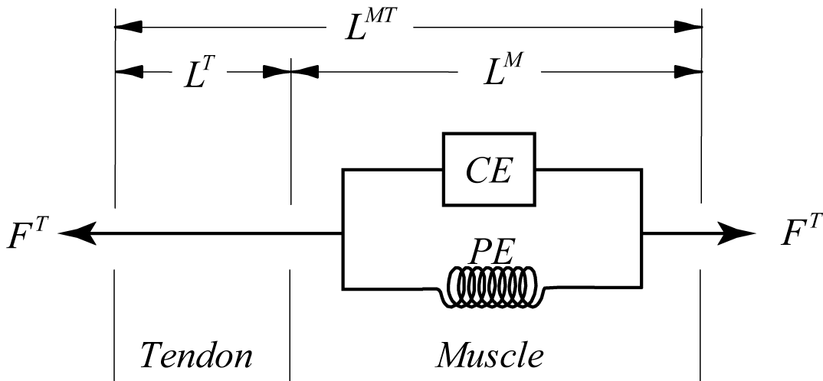
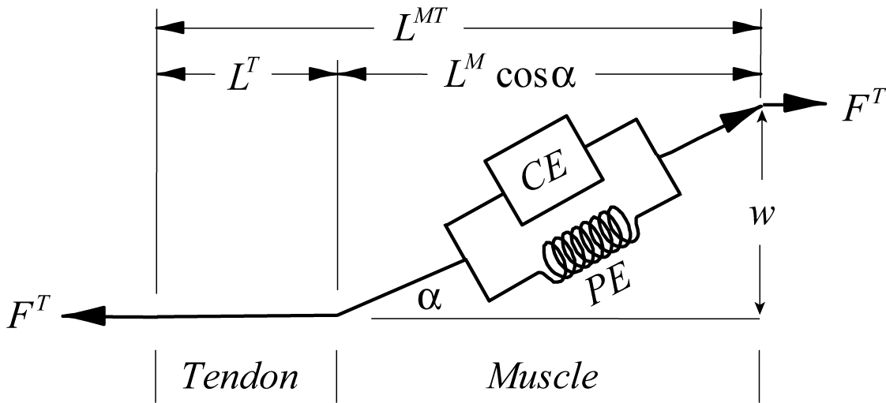

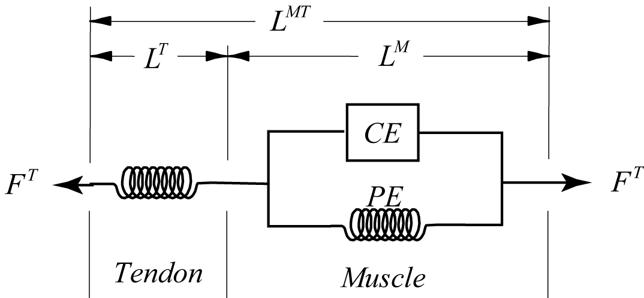
2a) Force-length-velocity
(p. 5)
2b) Force-length-velocity with pennation
(p. 7)
3a) Force-length-velocity with elastic tendon
(p. 9)
REFERENCES
(p. 13)
Model 1a: Simplest
1. Tendon is infinitely stiff.
2. Force production by the muscle has no dependence on its length or velocity.
3. The muscle fibers act in the same direction as the tendon.
parameters:
time-varying inputs:

The simplest possible muscle neglects all but the strength () and activation level () of a muscle.

(1)

The activation, , is like a control knob for turning up and down the force. Its value is usually chosen based on experimental conditions or comes from a control algorithm that is used to drive a musculoskeletal model to track some desired motion. , usually expressed in Newtons, is typically obtained from the literature. Literature values can be scaled to match the strength of an individual, if strength measurements are available for that individual.

Model 1b: Simplest Possible with Pennation
1. Tendon is infinitely stiff.
2. Force production by the muscle has no dependence on its length or velocity.
3. The muscle fibers act at a pennation angle, , to the line of action of the tendon.
parameters: ,, ,
time-varying inputs: ,

This model is the same as Model 1a, except that the pennation angle of the muscle fibers, , is taken into account.

The force exerted by the tendon on bone is the force in the contractile element multiplied by the cosine of the pennation angle:

, (2)

where we have used Eq. (1) to substitute for .

The pennation angle changes as the length of the muscle changes. To compute how changes, it is often assumed that the width of the muscle, , remains constant, so that the following is always true

. (3)

The value of can be computed from the optimal fiber length and the optimal pennation angle:

. (4)

and are input parameters that are typically obtained from the literature for the particular muscle in question (e.g., Delp et al., 1990; Anderson et al., 1999; Garner et al., 2001, Holzbaur et al., 2005). Together with the knowledge of the total actuator length, , and the tendon slack length, , the pennation angle (or even better the ) can be computed. The total length of the actuator is given by

. (5)

Note that because tendon is assumed to be infinitely stiff, we can use for . Using along with Eqs. (3) and (5), you can show that

(6)

Substituting for in Eq. (2), the equation for the force generated by the actuator is thus given by

(7)

As long as , Eq. (7) produces a well defined value. If ever (i.e., the muscle is slack), the force generated by the tendon is zero. If a muscle’s fibers are not pennate and the width of the muscle is zero (), Eq. (1) should be used.

The total length of an actuator, , is determined by the path geometry of the actuator. It can be determined in many cases from the kinematics of the musculoskeletal model (e.g., by computing the distance from the muscle origin to the muscle insertion). The tendon slack length, on the other hand, is more difficult to determine; a length cannot generally be measured. The value is typically chosen by the modeler (you) so that the muscle generates force over the appropriate range of total actuator lengths or joint angles.

Model 2a: Force-Length-Velocity Properties of Muscle with Inelastic Tendon
1. Tendon is infinitely stiff.
2. Force production by the muscle depends non-linearly on its length and velocity and is the sum of an active component, the contractile element (), and a passive component, the parallel elastic element ().
3. The muscle fibers act in the same direction as the tendon.
parameters: , ,,
time-varying inputs: ,,

This model is similar to Model 1a, but now there is parallel elastic element in addition to the contractile element, and force production depends on the length and shortening velocity of the muscle, and respectively.

The force in the tendon is given by

. (8)

The contractile element force will be assumed to have the same form as Eq. (1) except that it is modified by the product of two normalized terms, one expressing the length dependence, , and the other the velocity dependence, :

(9)

can be modeled by a Gaussian-like function (Thelen, 2003), and can be modeled by a sigmoidal:

(10)

(11)

The parameters and are typically found in the literature (e.g., Delp et al., 1990; Anderson and Pandy, 1999; Garner and Pandy, 2001; Holzbaur et al., 2005). varies from muscle to muscle. is about 4.0 optimal fiber lengths per second for slow-twitch muscle and as high as 10.0 optimal fiber lengths per second for fast-twitch muscle (refs??).

Fig. 1: Force-length properties of fully
activated muscle. Eqs (10) and (12).
Fig. 2: Force-velocity properties of fully
activated muscle. Eq (11).

The parallel elastic element can be modeled with an exponential as well:

. (12)

The problem now is to find the length and shortening velocity of muscle, given the overall length and shortening velocity of the actuator. The length of the muscle is given by

. (13)
Time differentiation of Eq. (13), and noting that because tendon is assumed to be infinitely stiff, yields the following equation for the shortening velocity of muscle:

. (14)

Eqs. (10) - (12) only approximate the length and velocity dependencies of muscle. The nice thing about them is that they are simple and can be expressed in computer code easily. For more accurate models, one can use curve fits (polynomials, splines, …) of experimental data.

Model 2b: Force-Length-Velocity Properties of Muscle with Inelastic Tendon and Pennation
1. Tendon is infinitely stiff.
2. Force production by the muscle depends non-linearly on its length and velocity and is the sum of an active component, the contractile element force (), and a passive component, the parallel elastic element force ().
3. The muscle fibers act at a pennation angle, , to the line of action of the tendon.
parameters: , ,, ,
time-varying inputs: ,,

This model is similar to Model 2a, but pennation angle is included.

The force in the tendon is given by

, (15)

where and are computed the same as above for Model 2a (Eqs. (9)-(12)). Also, as developed previously, can be computed using Eq. (6). The computations for the length and shortening velocity of the muscle are different, however. The following relation governs the length of muscle:

. (16)

So, with some algebra, Eq. (16) yields

. (17)

Derivation of the shortening velocity, , is more involved because the pennation angle, , varies as a function of time. Using the product rule and the chain rule for differentiation on Eq. (16) yields

. (18)

Using the assumption that the muscle width remains constant, time differentiation of Eq. (3) yields

. (19)
Solving Eq. (19) for , and substituting into Eq. (18) leads to

. (20)

Simplifying Eq. (20) then leads to

, (21)

which, using , conveniently leads to

. (22)

Thus, Eqs. (17) and (22) can be used to compute the length and shortening velocity of muscle, and these can be used in Eq. (15) to calculate the force in the tendon.

It is interesting to note for a pennate muscle that, while the force in the tendon is less than the force in the muscle because ,

, (23)

the shortening velocity along the tendon is greater than the shortening velocity of the muscle:

. (24)

In this model, since tendon is assumed to be inelastic, it cannot store energy. This means that any work done by the actuator must be the same as that done by the muscle. Multiplying Eqs. (23) and (24) together verifies that this is the case:

!! (25)

Model 3a: Force-Length-Velocity Properties of Muscle with Elastic Tendon (1st-Order ODE)
1. Tendon is elastic with a linear stress-strain relationship.
2. Force production by the muscle depends non-linearly on its length and velocity and is the sum of an active component, the contractile element force (), and a passive component, the parallel elastic element force ().
3. The muscle fibers act in the same direction as the tendon.
parameters: , ,, ,
time-varying inputs: ,,

With elastic tendon, it is generally not possible to write a closed-form expression for tendon force. The reason is that it is not possible to determine the shortening velocity of muscle uniquely given the shortening velocity of the actuator. Both the shortening velocity of tendon and muscle contribute to the shortening velocity of the actuator:

(26)

(27)

Computing the force output of the actuator requires a first-order (or higher) ordinary differential equation that is usually nonlinear. In this model, tendon force is chosen as the dependent variable of the differential equation. Other choices for the dependent variable, such as the length of the muscle, are also possible (Shutte et al., 1993). The equations for modeling force will therefore have the form

. (28)

The time history of force can then be obtained by integrating Eq. (28) given an initial value for the force:

. (29)

The basic relationships for this model are the same as for Model 2a, except now there is an additional equation for the force developed by tendon that depends linearly on the length of the tendon:

. (30)

The stress-strain properties of tendon are approximated reasonably well by the following linear relationship:

; . (31)

The stress in tendon, across different muscles, has generally been estimated to be 32 MPa when the muscle is generating its optimal force (Zajac, 1989). We therefore have the following relationships:

(32)

; , (33)

where is the cross-sectional area of tendon. Solving Eq. (33) for , and substituting into Eq. (32), yields

. (34)

Thus, the stiffness for a tendon can be approximated knowing the slack length of the tendon and the optimal force of the muscle:

. (35)

Now, back to the development of first-order differential equation for actuator force... The shortening velocity of tendon is related to the time derivative of tendon force:

. (36)

Using Eq. (27), Eq. (36) can be written in terms of the shortening velocity of the actuator and muscle:

(37)

can be computed from the path geometry of the muscle. To complete development of the differential equation, the trick now is to use the force-length-velocity properties of muscle to solve for . This is just the inverse of the force velocity curve expressed by Eq. (11) and shown in Fig. 2, and it will depend upon the muscle length and the force developed by the contractile element:

. (38)

How to compute , , and the inverse of the force-velocity curve is described next. Given , the muscle length can be computed from Eqs. (26) and (30):

(39)

From Eq. (8), the force in the contractile element is

. (40)

Since is known from Eq. (39), can be computed using Eq. (12). And, since is known at the current time, can be computed using Eq. (40).

From Eq. (9), the force in the contractile element is also given by

. (41)

Isolating in Eq. (41), we find

(42)

Now, the inverse of Eq. (42) can be used to solve for . That is, given the force-velocity property of muscle, we would like to know the shortening velocity of muscle given its force and length. Defining as the ratio of the actual contractile force to the isometric contractile force,

, (43)

and taking the inverse of the normalized force-velocity curve, (i.e., the inverse of Eq. (11)), the muscle shortening velocity becomes

. (44)

Note that in Eq. (43) is evaluated using Eq. (10).

The inverse expressed in Eq. (44) doesn’t need to be an analytic inverse of Eq. (11). It can simply be a curve fit of the inverse. Simply turn the plot in Fig. 2 on its side, making a dependent variable, and do another curve fit. A sum of exponentials, for example, can be used for the curve fit:

(45)

Fig. 4: Inverse of the force-velocity property of muscle. Eq. (45).

So, finally, from Eqs. (37) and (45), we get an expression for the time derivative of force in the tendon:

(46)

References

Anderson FC, Pandy MG (1999). A Dynamic Optimization Solution for Vertical Jumping in Three Dimensions. Computer Methods in Biomechanics and Biomedical Engineering 2: 201-231.

Delp SL, Loan JP, Zajac FE, Topp EL, Rosen JM (1990). An Interactive Graphics-Based Model of the Lower Extremity to Study Orthopaedic Surgical Procedures. IEEE Transactions on Biomedical Engineering 37: 757-767.

Garner BA, Pandy MG (2001). Musculoskeletal Model of the Upper Limb Based on the Visible Human Male Dataset. Computer Methods in Biomechanics and Biomedical Engineering 4: 93-126.

Holzbaur KR, Murray WM, Delp SL (2005). A model of the upper extremity for simulating musculoskeletal surgery and analyzing neuromuscular control. Annals of Biomedical Engineering 33: 828-840.

* McMahon TA (1984). Muscles, Reflexes and Locomotion. Princeton University Press, Princeton, NJ.

Schutte LM, Rodgers MM, Zajac FE. Glaser RM (1993). Improving the efficacy of electrical stimulation-induced leg cycle ergometry: an analysis based on a dynamic musculoskeletal
model. IEEE Transaction on Rehabilitation Engineering 1: 109–125.

Thelen DG (2003). Adjustment of Muscle Mechanics Model Parameters to Simulate Dynamic Contractions in Older Adults. Journal of Biomechanical Engineering 125: 71-77.

Zahalak GI (1992). Chapter 2: An Overview of Muscle Modeling in Neural Prostheses, Eds. Stein RB, Peckham PH, Popovic DB. Oxford University Press, Oxford: 17-57.

* Zajac FE (1989). Muscle and Tendon: Properties, Models, Scaling, and Application to Biomechanics and Motor Control. Critical Reviews in Biomedical Engineering 17: 359-411.

* McMahon (1984) and Zajac (1989) are excellent sources for basic muscle mechanics and modeling.

