Table S8. Structural formulas of the drug metabolism reactions and selected bacterial reactions from Table S7. Structural formulas for drug reactions are from PubChem. Each drug reaction is followed by the two nearest neighbors found in MetaCyc for bacteria, and their structural formulas from MetaCyc.
Reaction code | Reaction substrate | Reaction product
DM23 | 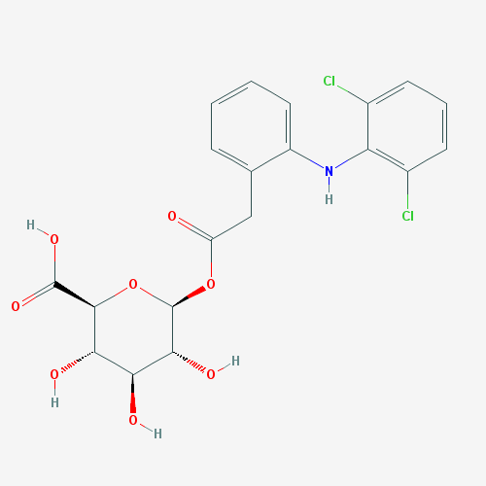 | 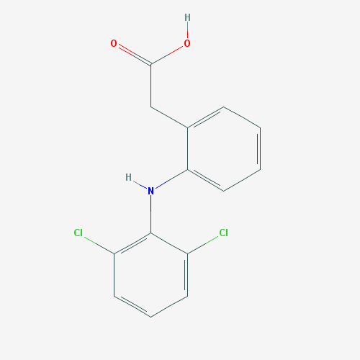
DM23 | Diclofenac glucuronide | diclofenac
RXN-17095 | 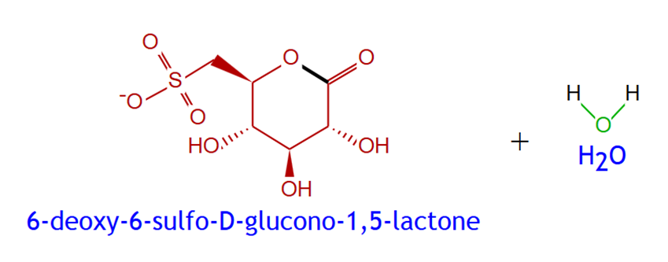 | 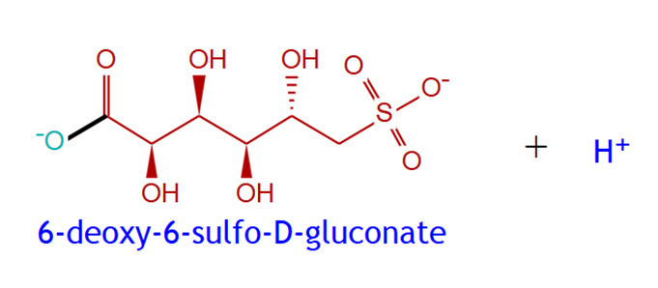
RXN-17095 | 6-deoxy-6-sulfo-D-glucono-1,5-lactone | 6-deoxy-6-sulfo-D-gluconate
RXN-9030 | 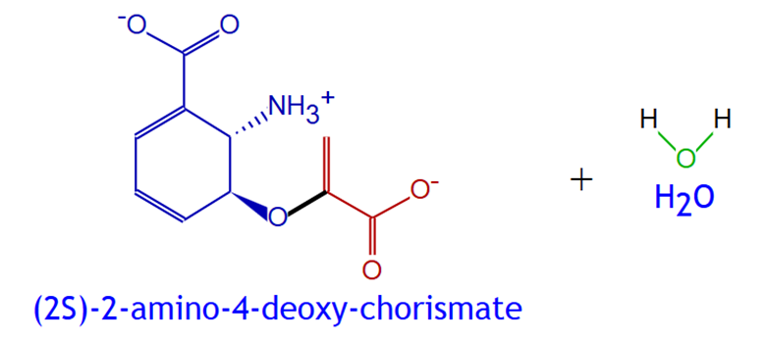 | 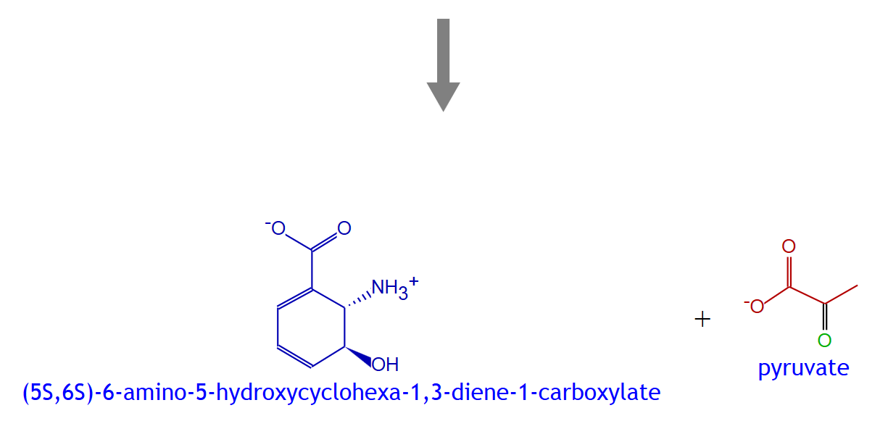
RXN-9030 | (2S)-2-amino-4-deoxy-chorismate | (5S,6S)-6-amino-5-hydroxycyclohexa-1,3-diene-1-carboxylate
DM22 | 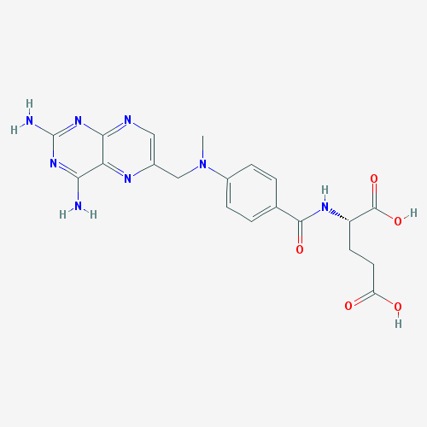 | 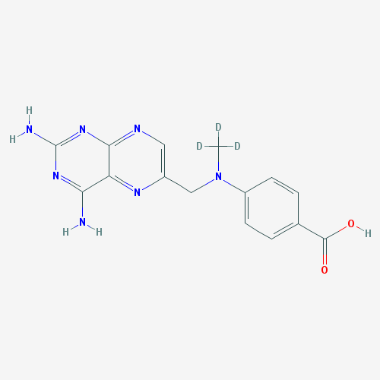
DM22 | Methotrexate | 4-amino-4-deoxy-N10-methylpteroic acid
RXN-17061 | 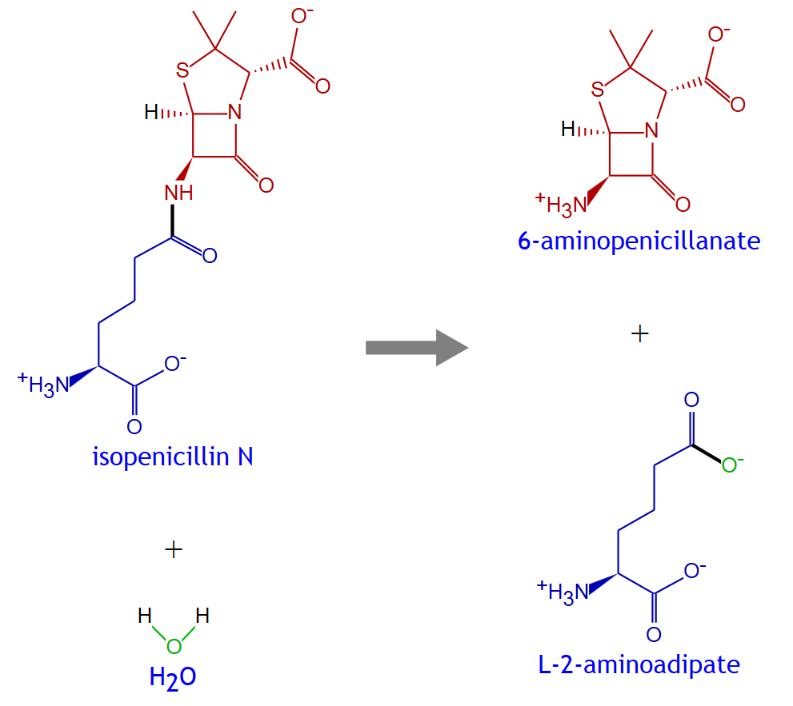  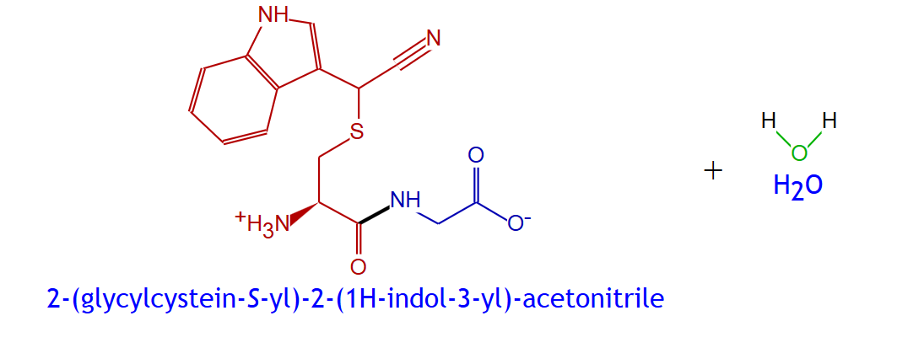
RXN-17061 | isopenicillin N | 6-aminopenicillanate
RXN-11665 |  | 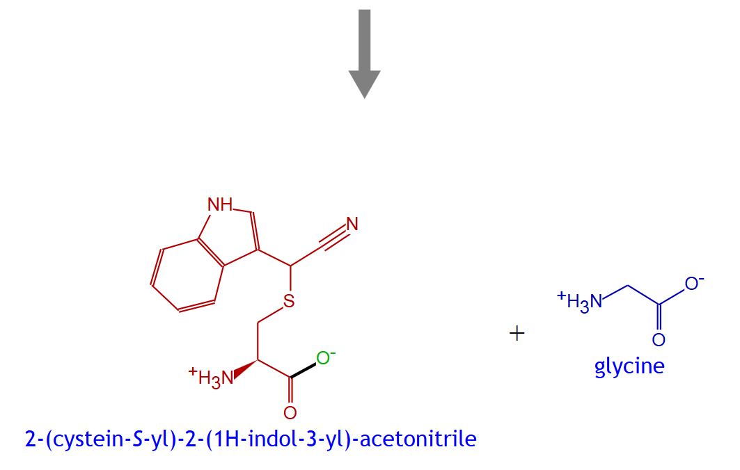
RXN-11665 | indole-3-acetonitrile-gamma-glutamylcysteine conjugate | indole-3-acetonitrile-cysteine conjugate
DM21 | 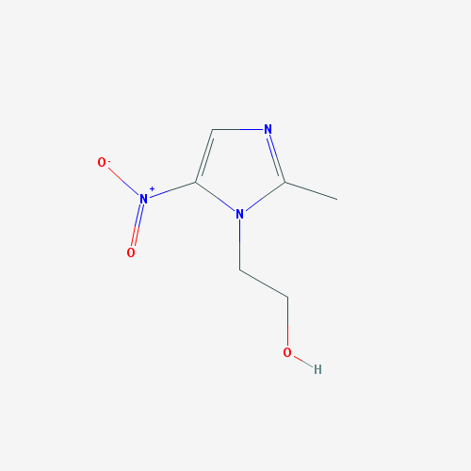 | 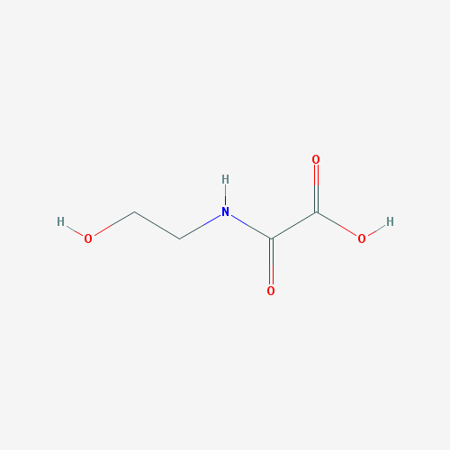
DM21 | Metronidazole | N-(2-hydroxyethyl)-oxamic acid
RXN-7587 | 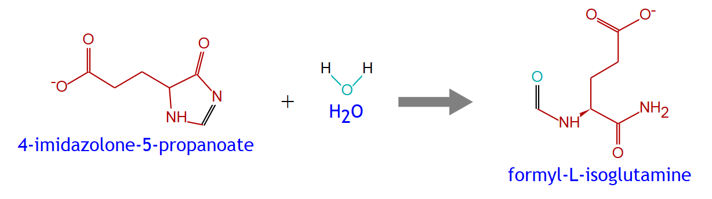
RXN-7587 | 4-imidazolone-5-propanoate | formyl-L-isoglutamine
RXN-15348 | 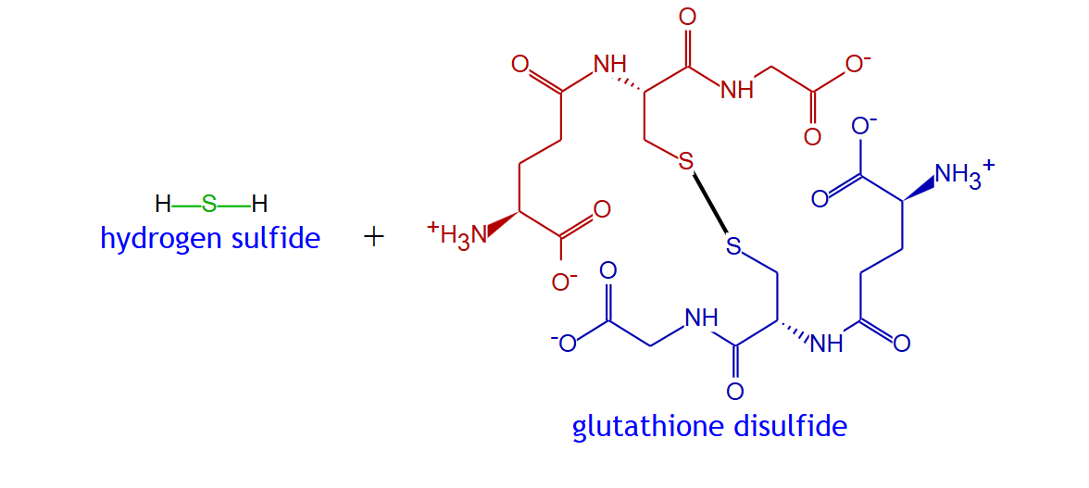 | 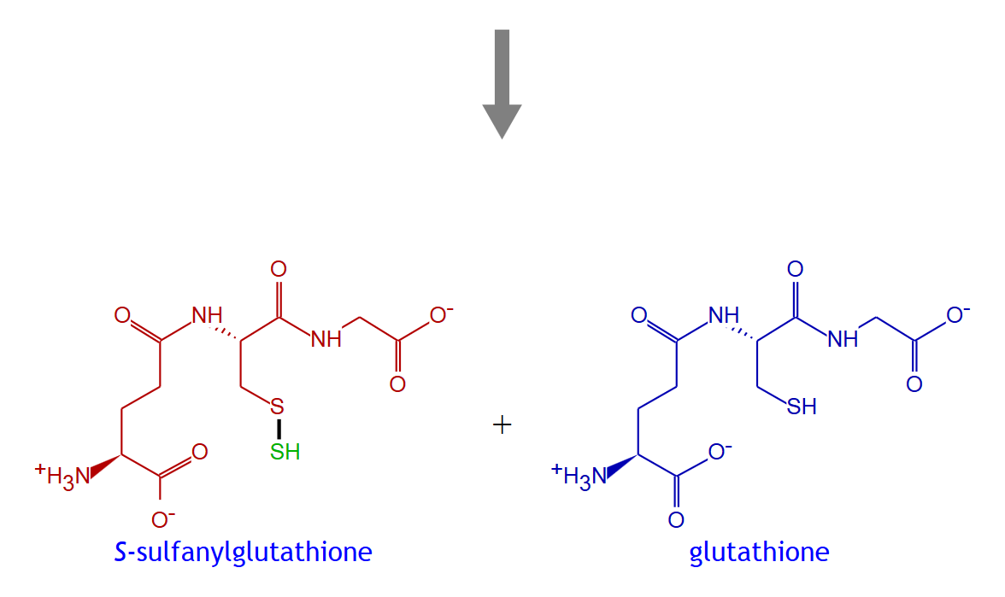
RXN-15348 | hydrogen sulfide | S-sulfanylglutathione
DM20 | 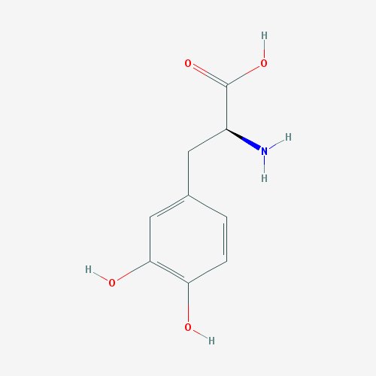 | 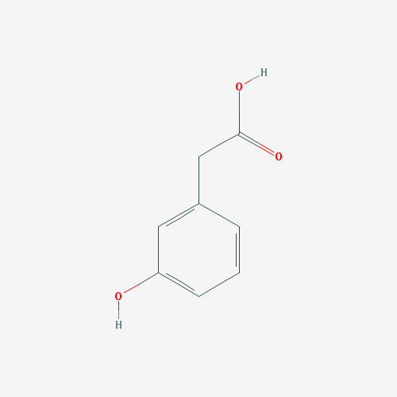
DM20 | Levodopa | m-tyramine
RXN66-221 | 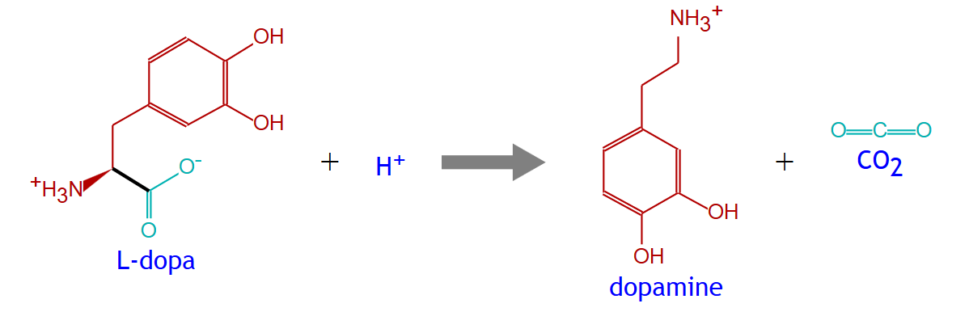
RXN66-221 | L-dopa | dopamine
RXN-10612 | 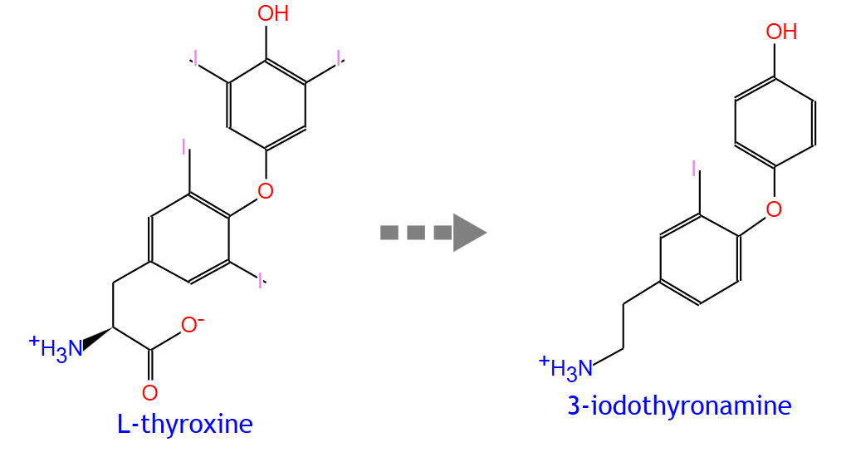
RXN-10612 | L-thyroxine | 3-iodothyronamine
DM12 | 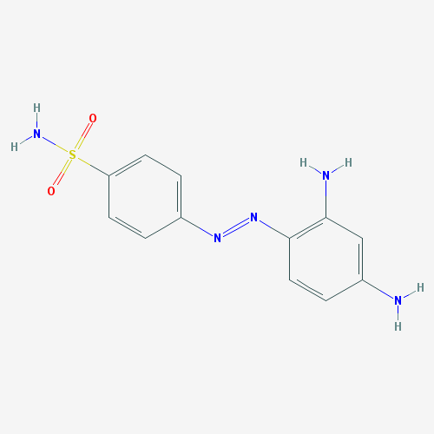 | 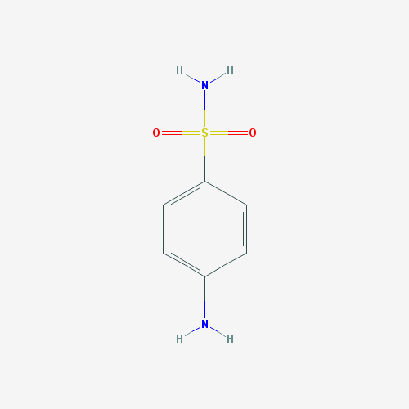
DM12 | Prontosil | sulphanilamide
MCHMBARK-RXN | 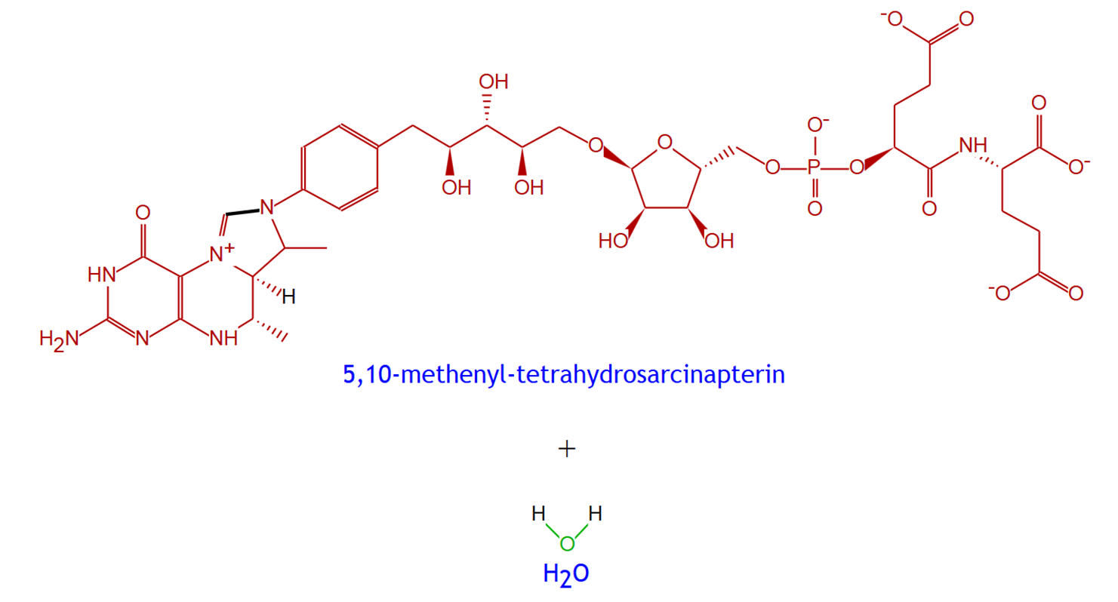 | 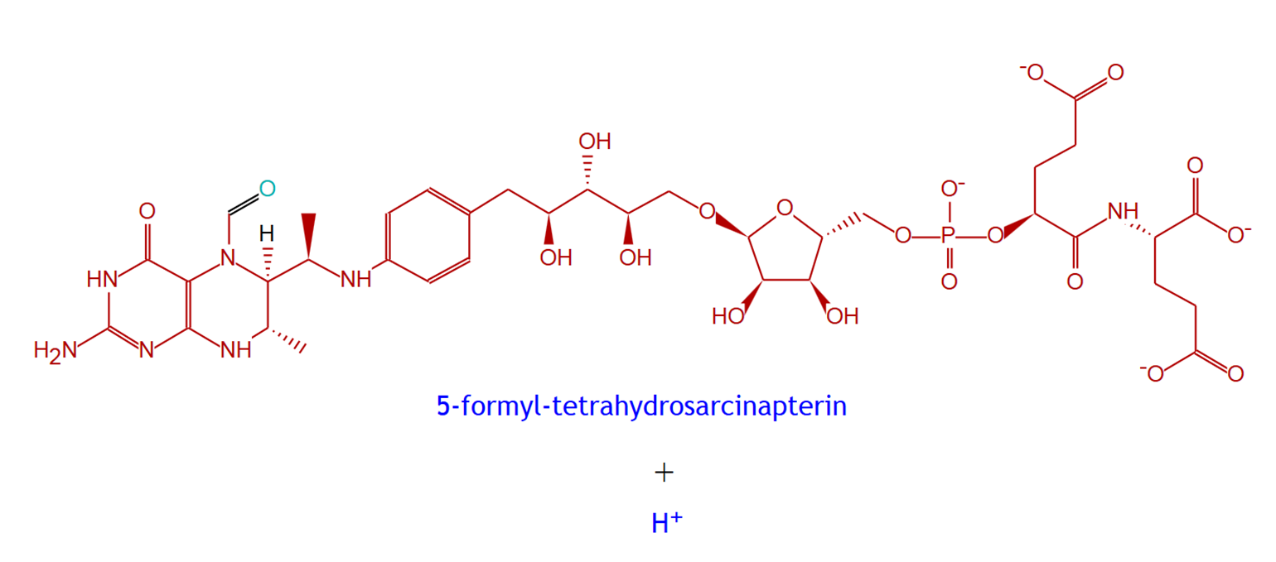
MCHMBARK-RXN | 5,10-methenyl-tetrahydrosarcinapterin | 5-formyl-tetrahydrosarcinapterin
3.5.4.27-RXN | 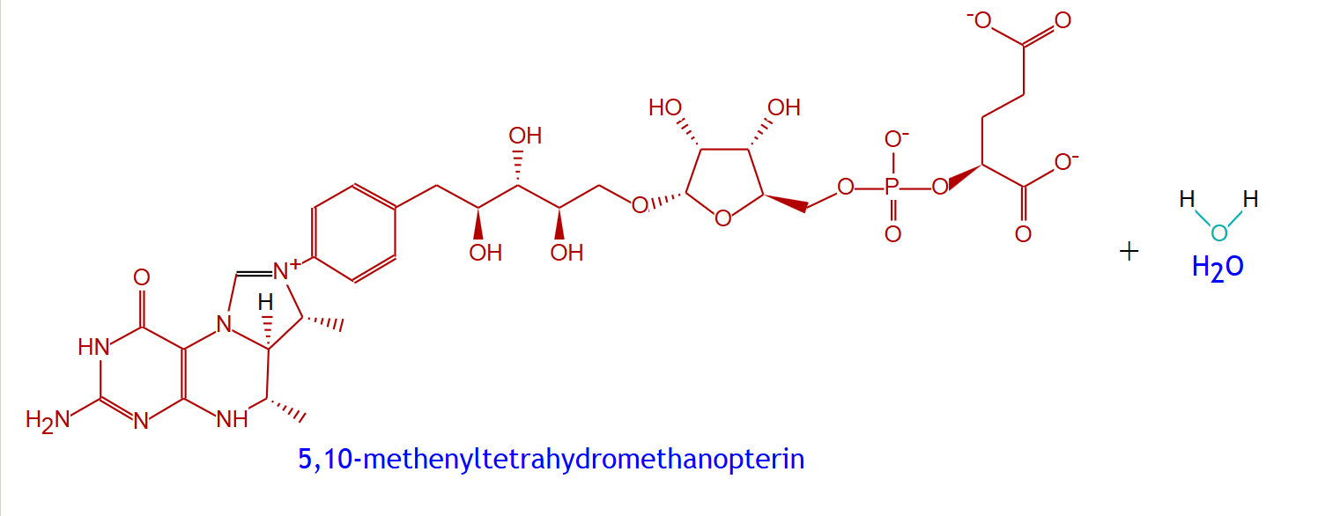 | 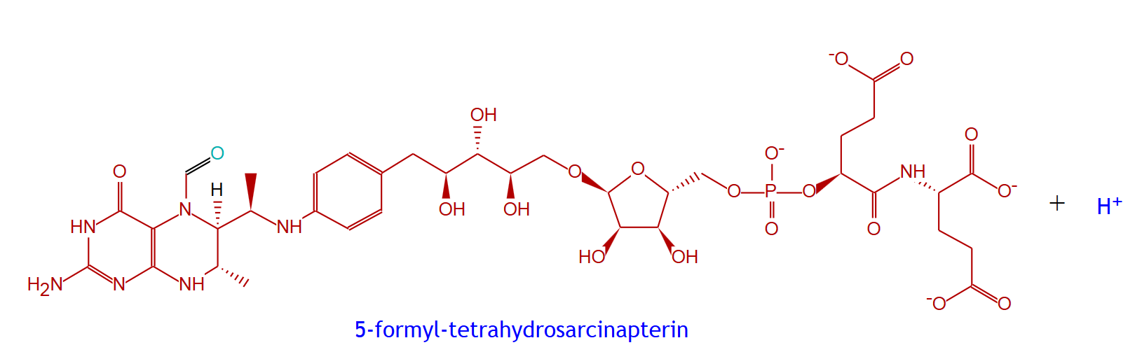  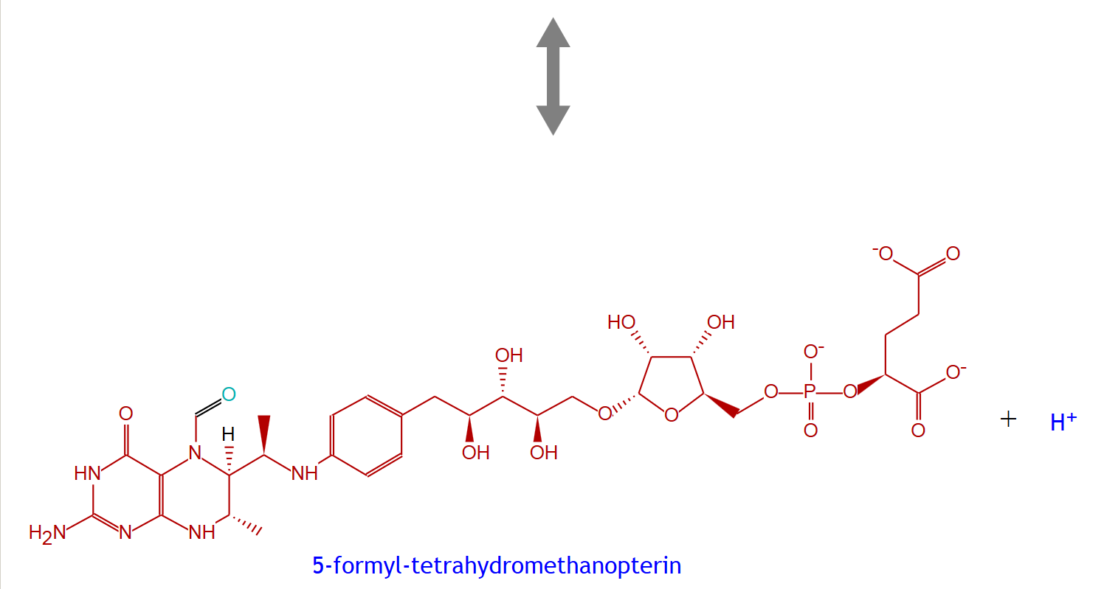
3.5.4.27-RXN | 5,10-methenyltetrahydromethanopterin | 5-formyl-tetrahydromethanopterin
DM13 | 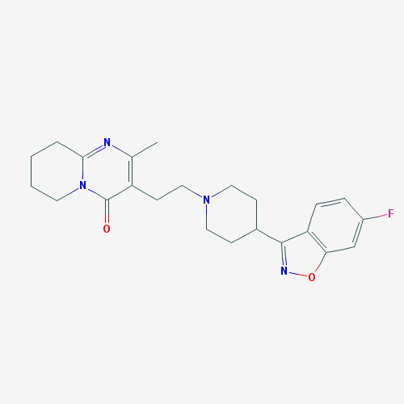 | 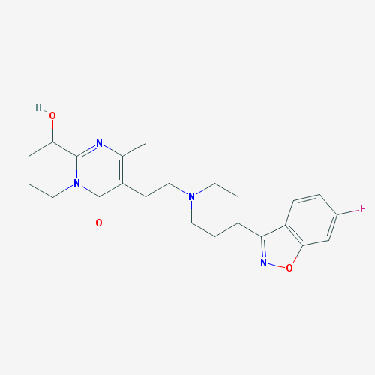
DM13 | Risperidone | 9-OH-RIS
RXN-8693 | 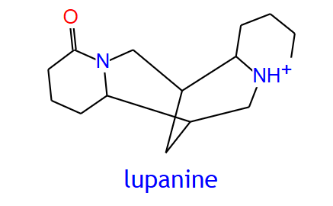 | 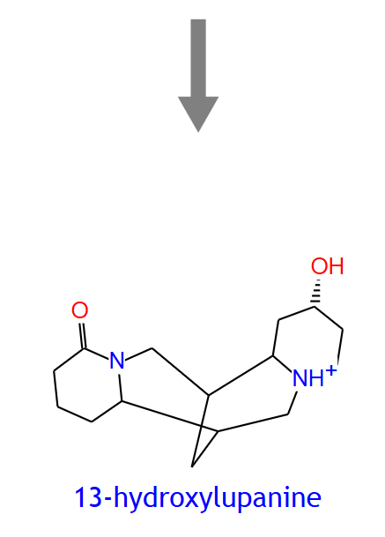
RXN-8693 | lupanine | 13-hydroxylupanine
RXN-11535 | 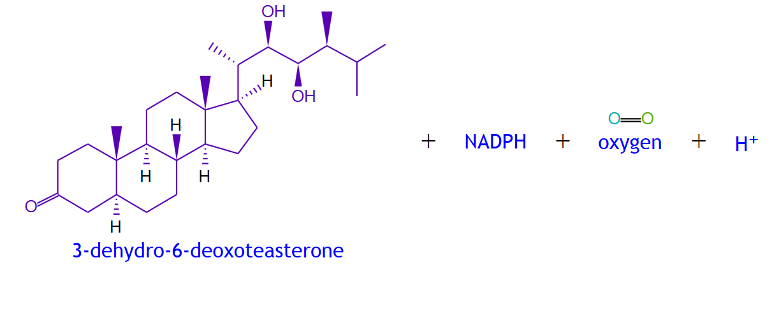 | 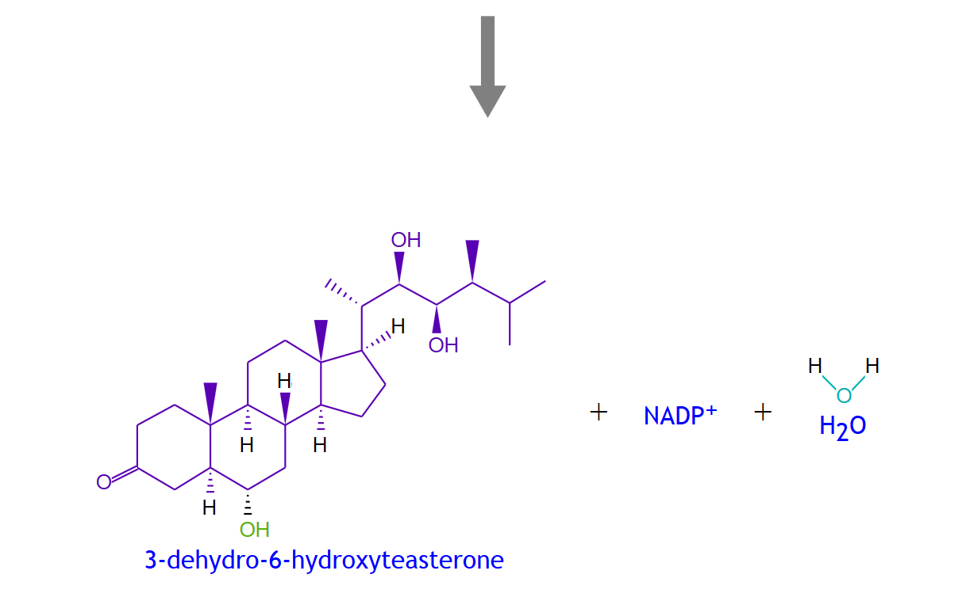
RXN-11535 | 3-dehydro-6-deoxoteasterone | 3-dehydro-6-hydroxyteasterone
DM10 | 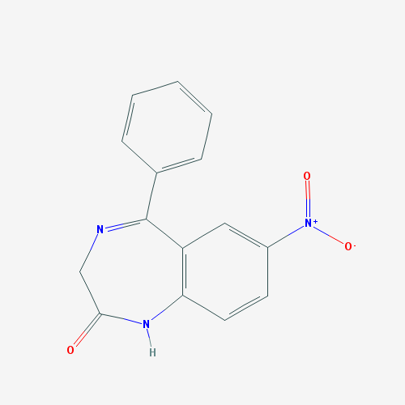 | 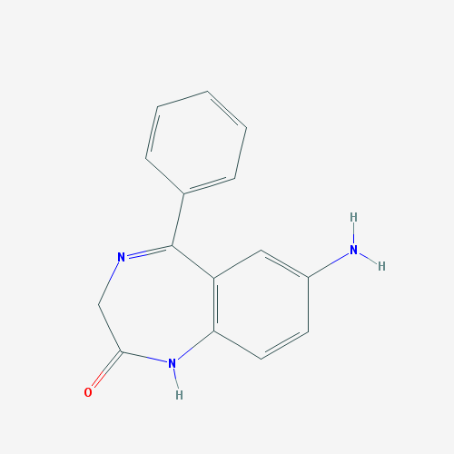
DM10 | Nitrazepam | 7-aminonitrazepam
RXN-8833 | 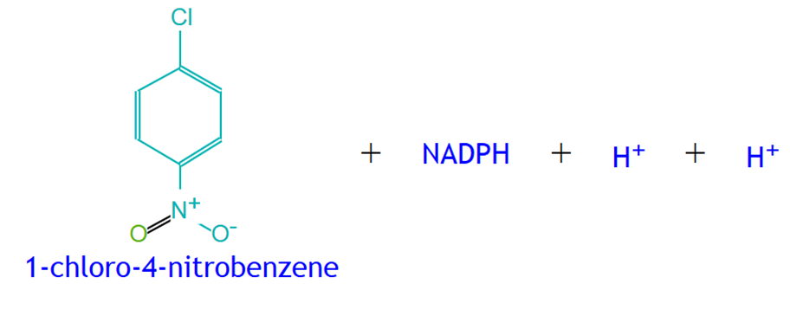 | 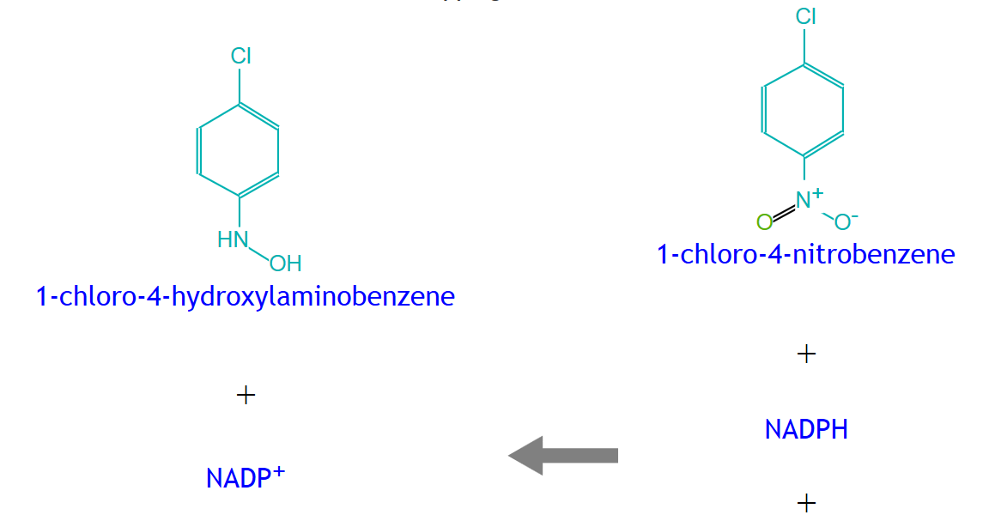
RXN-8833 | 1-chloro-4-nitrobenzene | 1-chloro-4-nitrosobenzene
RXN-12130
RXN-12130 | nitrous oxide | N₂
DM11 | 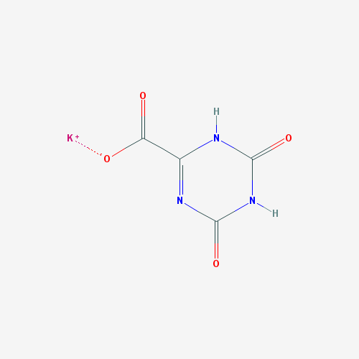 | 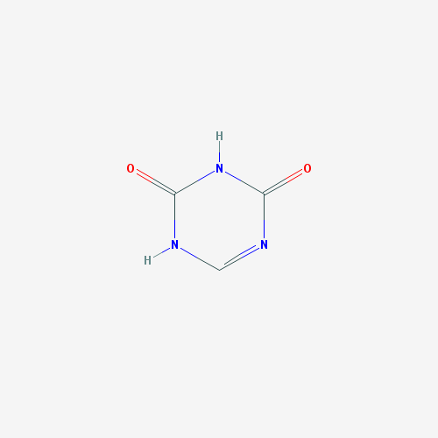
DM11 | Potassium oxonate | 5-azauracil (5-AZU)
RXN-13867 | 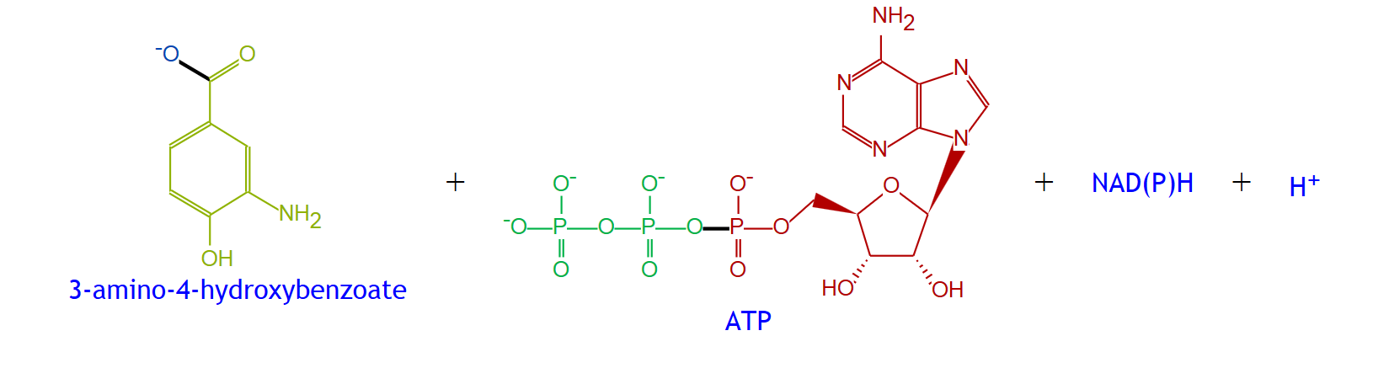 | 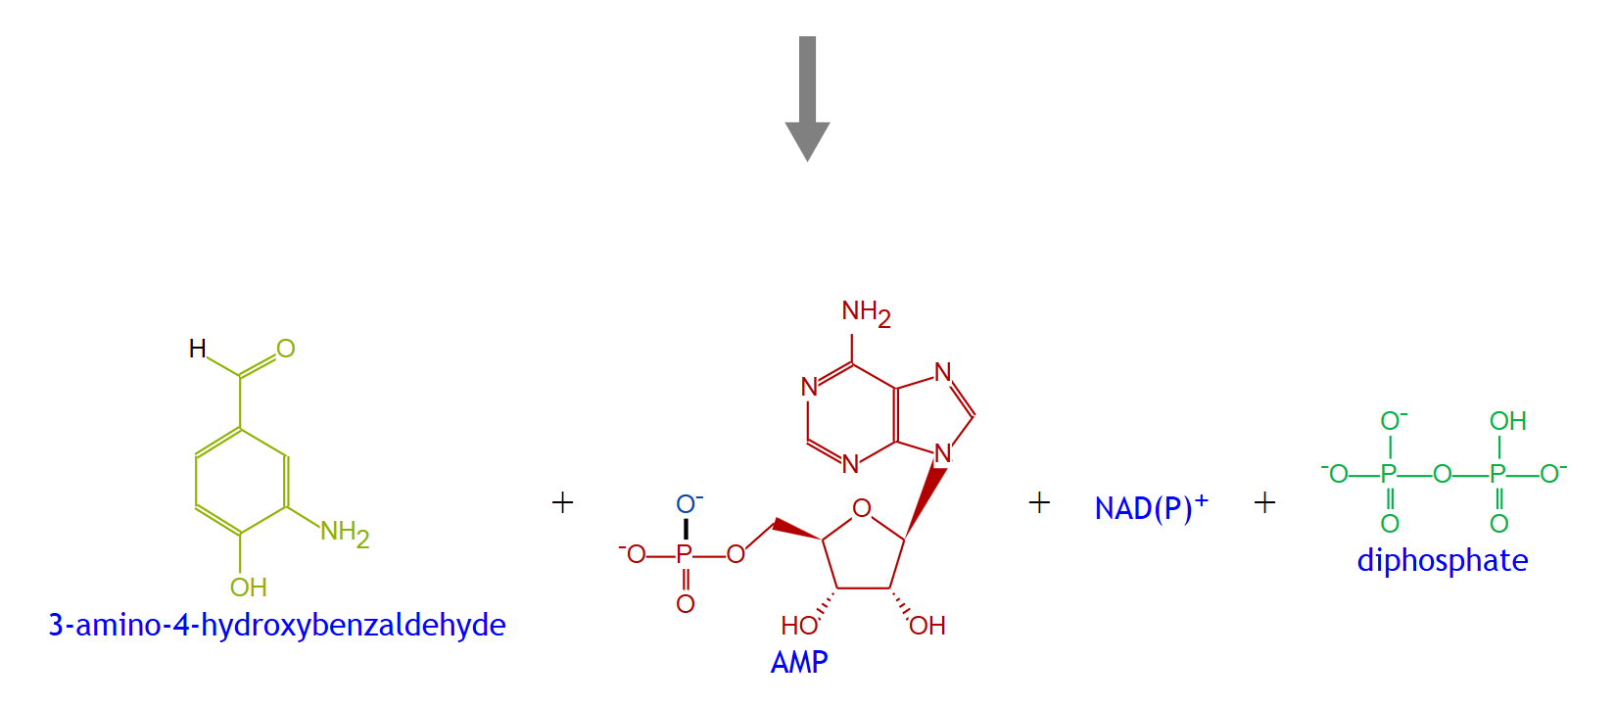
RXN-13867 | 3-amino-4-hydroxybenzoate | 3-amino-4-hydroxybenzaldehyde
RXN-12093 | 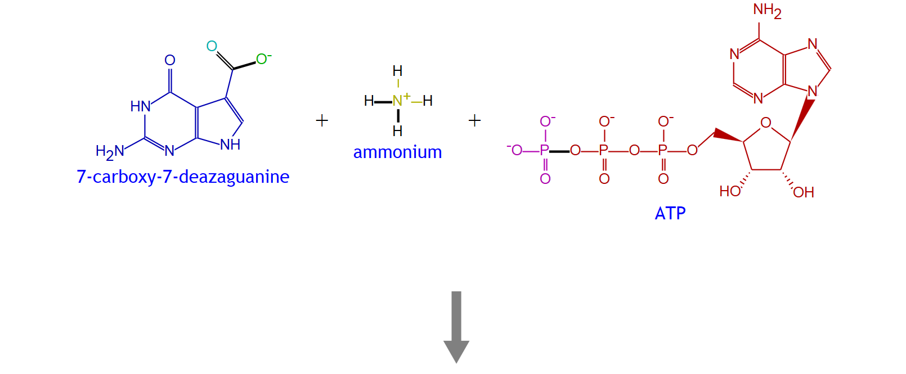 | 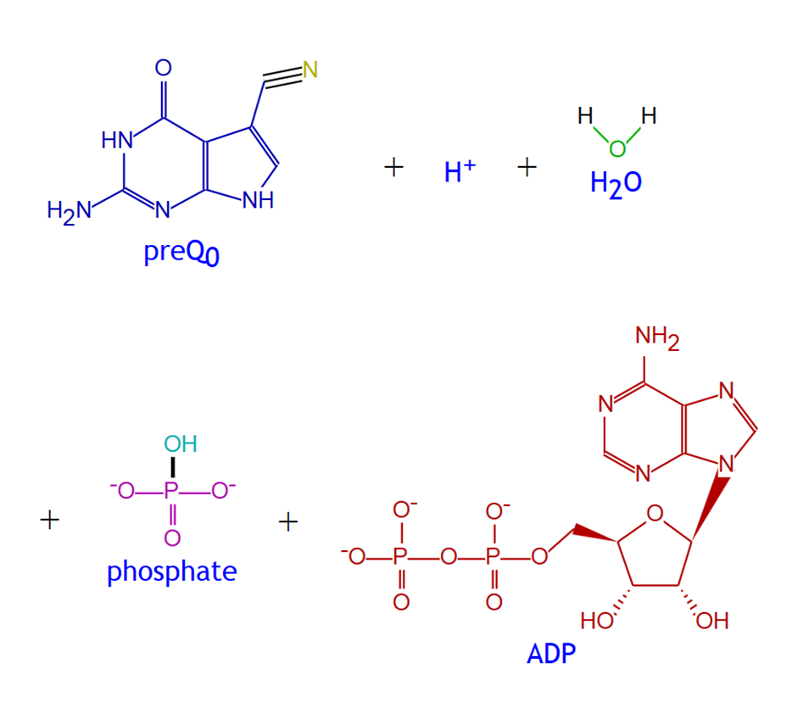
RXN-12093 | 7-carboxy-7-deazaguanine | preQ₀
DM16 | 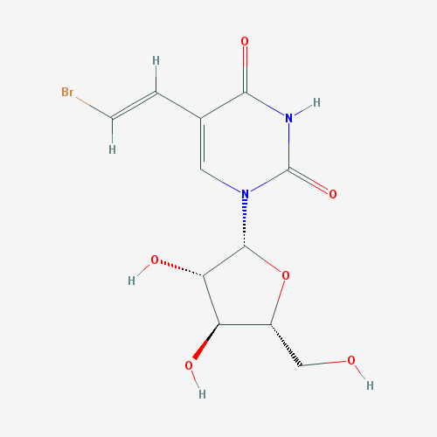 | 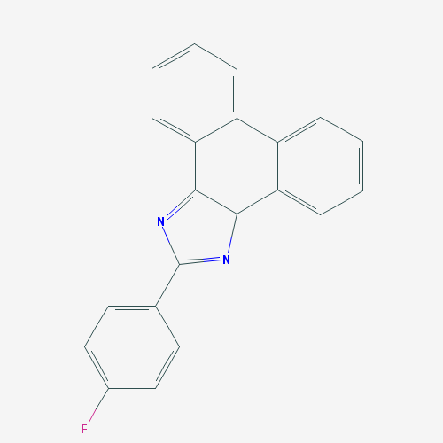
DM16 | Sorivudine | E-5-(2-bromovinyl)uracil
NICONUCADENYLYLTRAN-RXN | 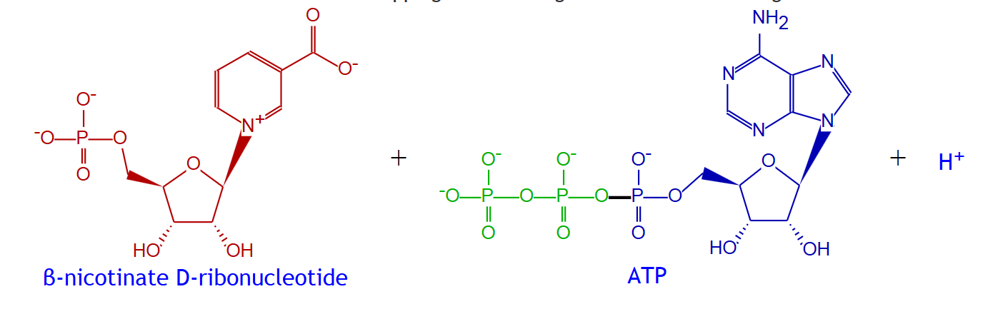 | 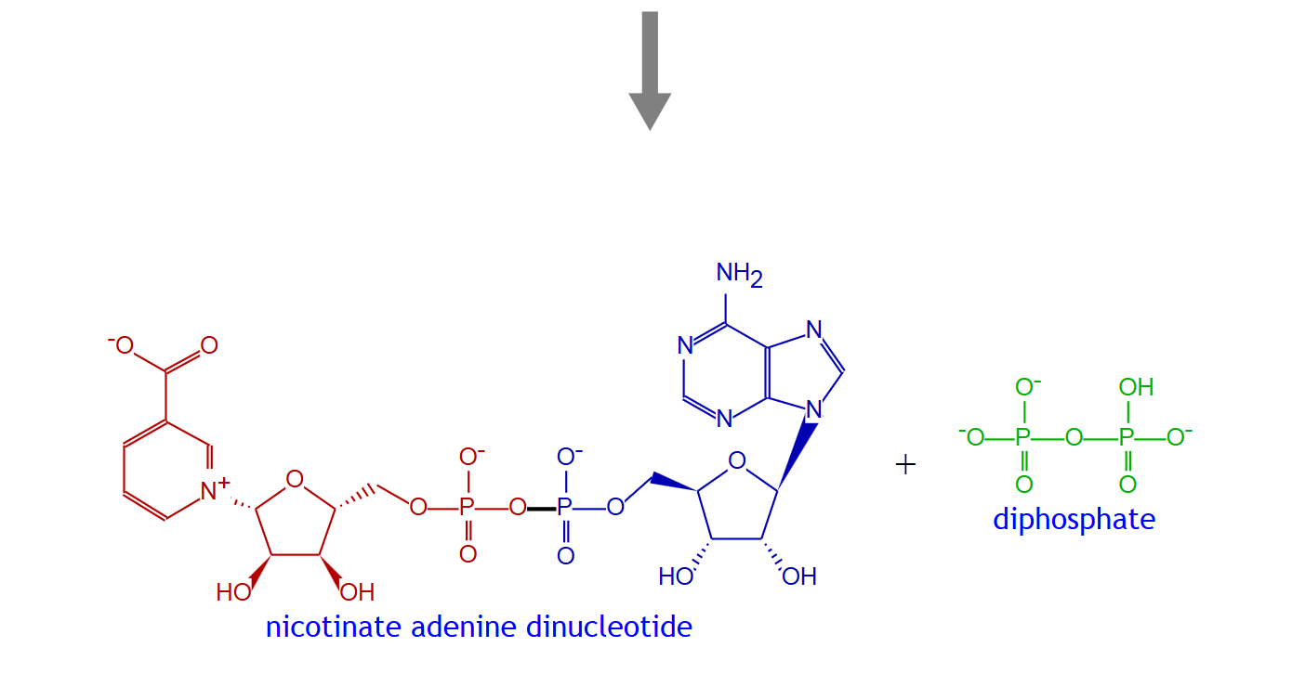
NICONUCADENYLYLTRAN-RXN | beta-nicotinate D-ribonucleotide | nicotinate adenine dinucleotide
RXN-4541 | 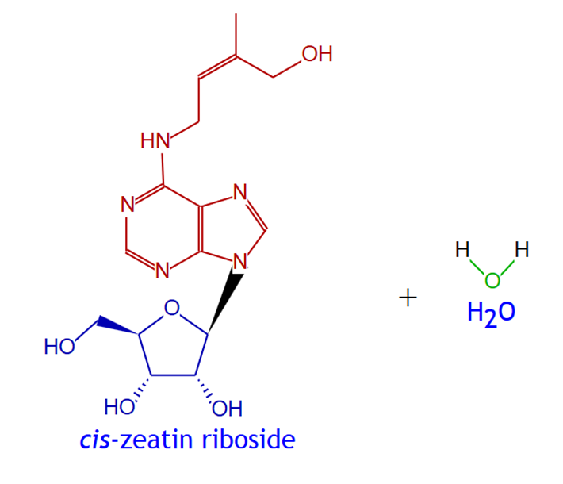 | 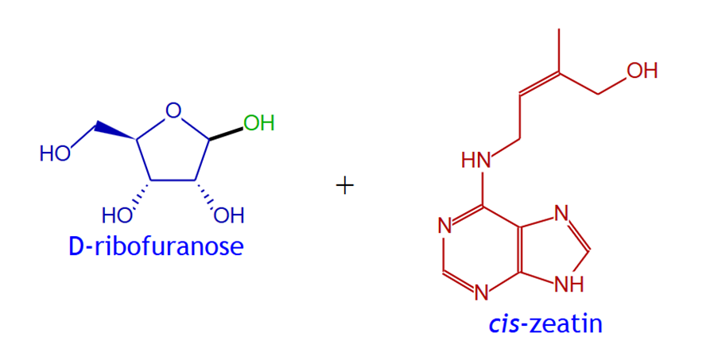
RXN-4541 | cis-zeatin riboside | cis-zeatin
DM17 | 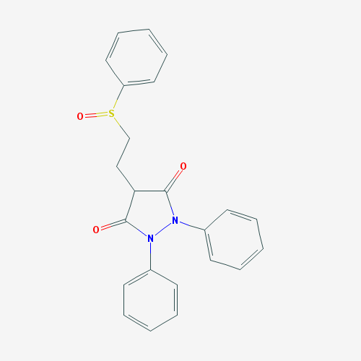 | 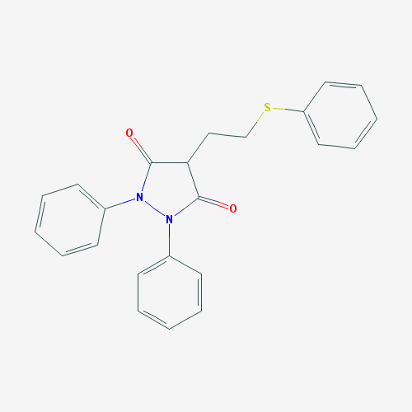
DM17 | Sulfinpyrazone | Sulfinpyrazone sulfide
RXN-17166 | 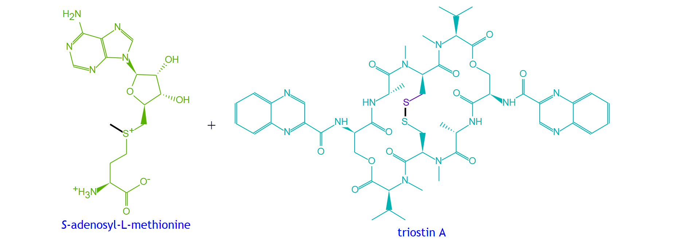 | 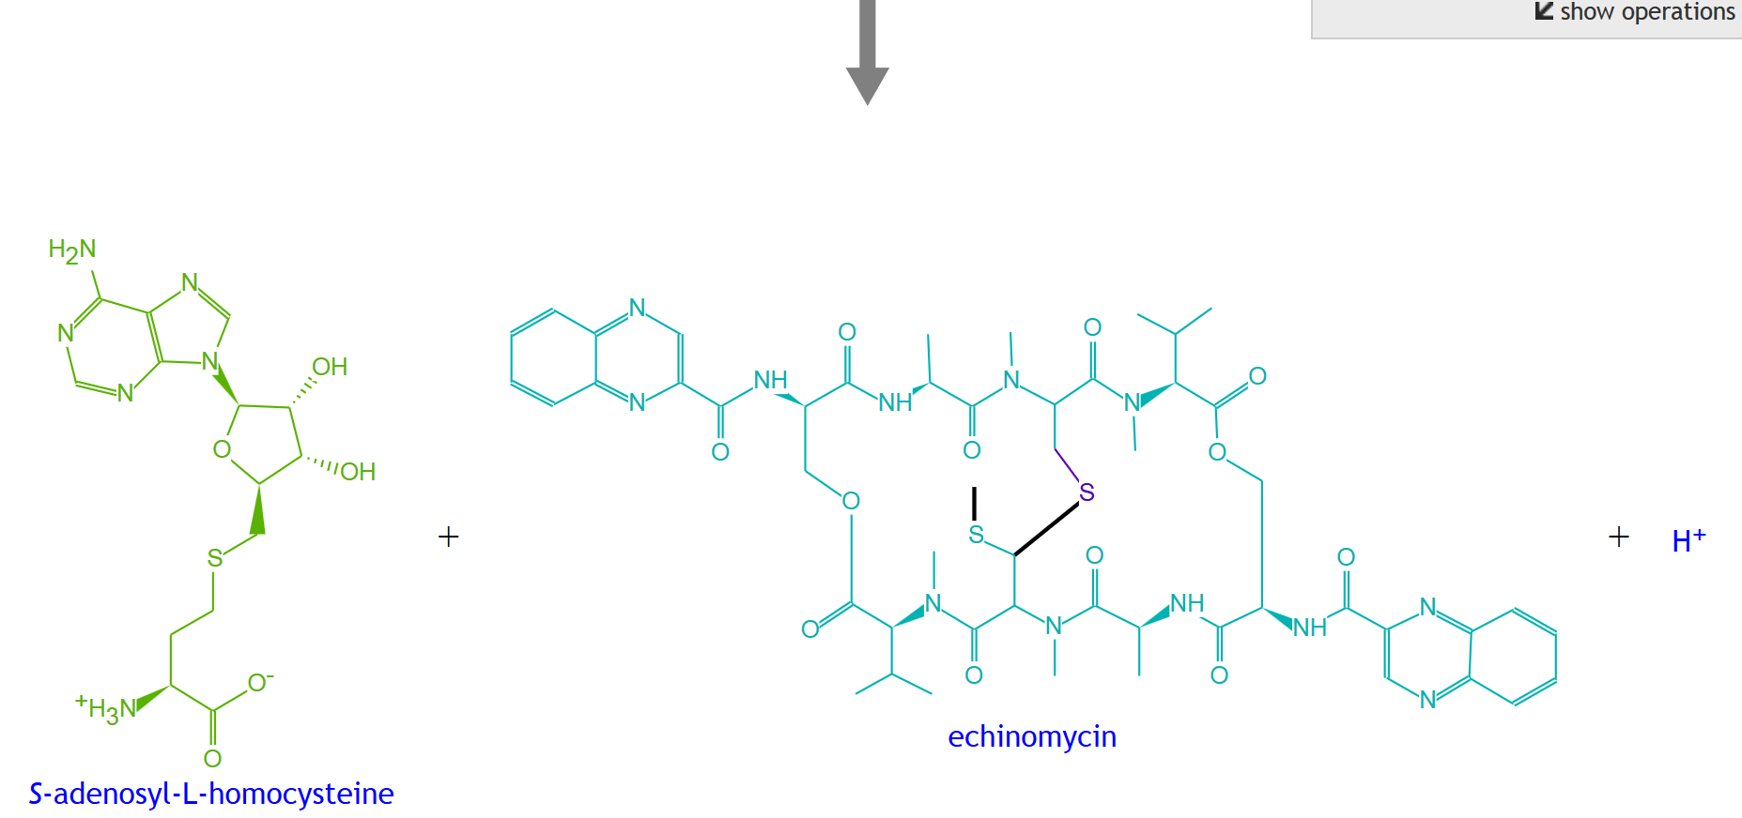
RXN-17166 | triostin A | echinomycin
RXN-9314 | 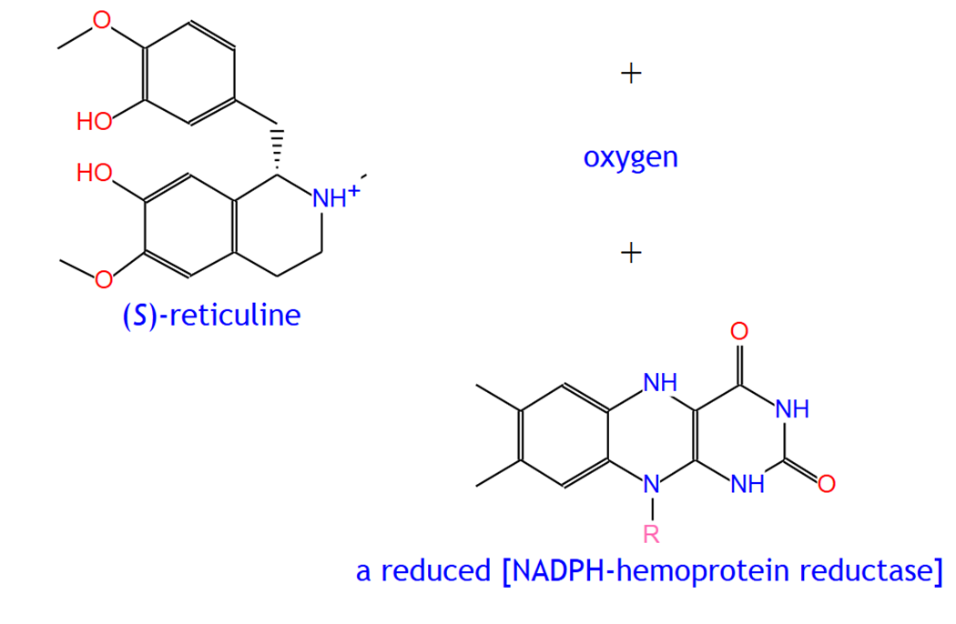 | 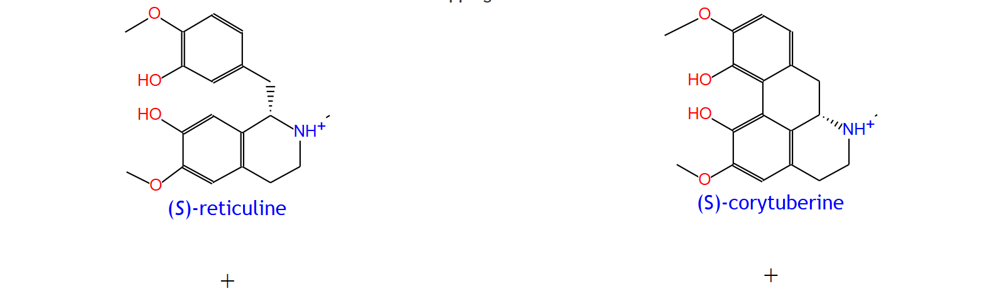  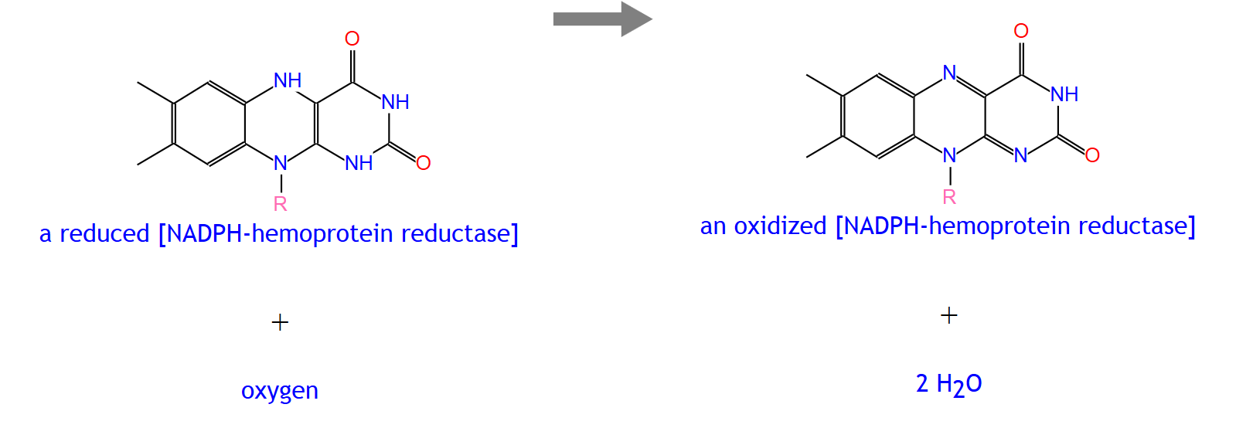
RXN-9314 | (S)-reticuline | (S)-corytuberine
DM14 | 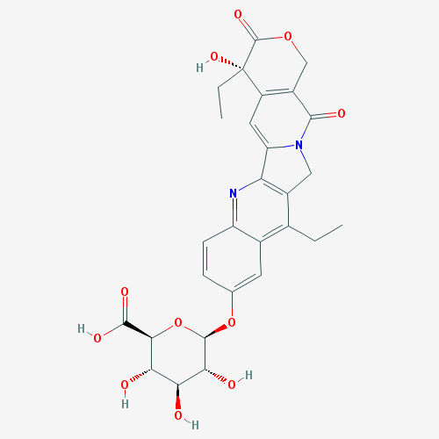 | 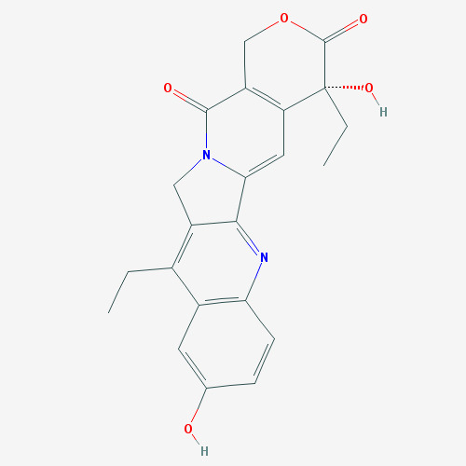
DM14 | SN-38G | SN-38
RXN-16479 | 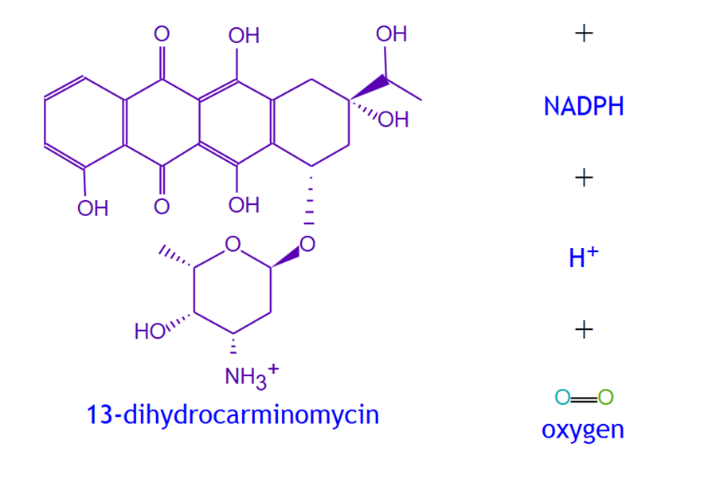 | 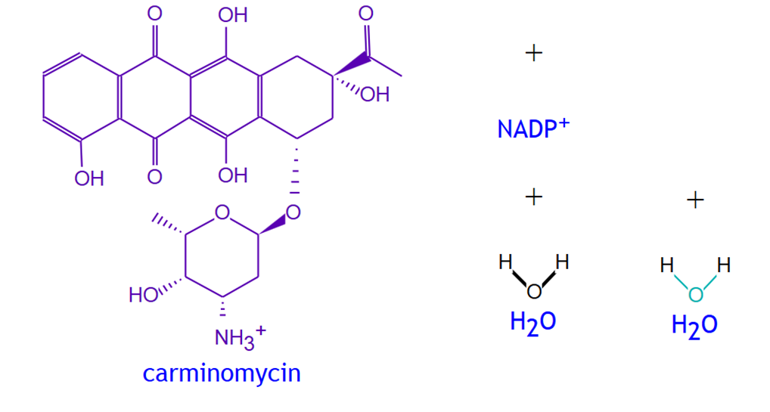
RXN-16479 | 13-dihydrocarminomycin | carminomycin
RXN-13632 | 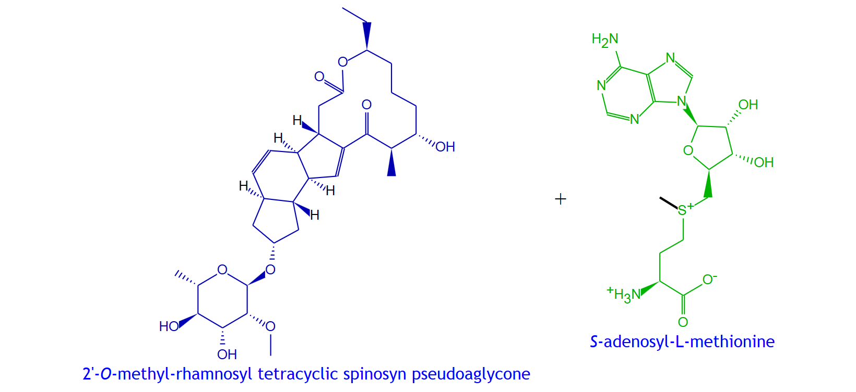 | 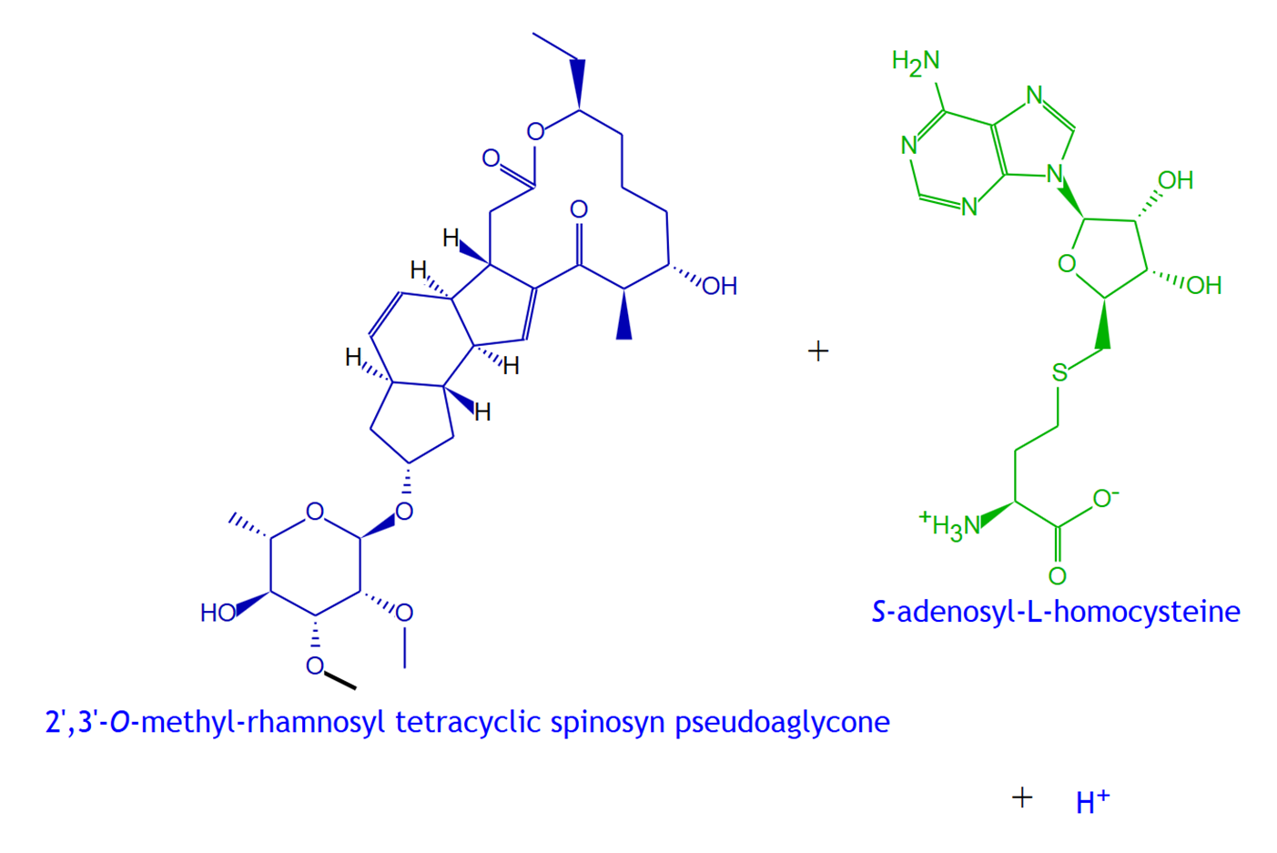
RXN-13632 | 2'-O-methyl-rhamnosyl tetracyclic spinosyn pseudoaglycone | 2',3'-O-methyl-rhamnosyl tetracyclic spinosyn pseudoaglycone
DM15 | 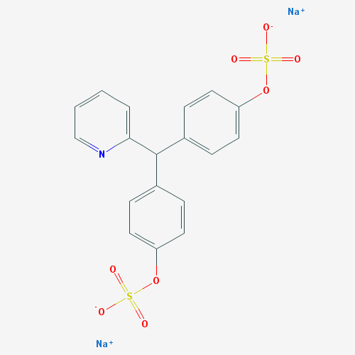 | 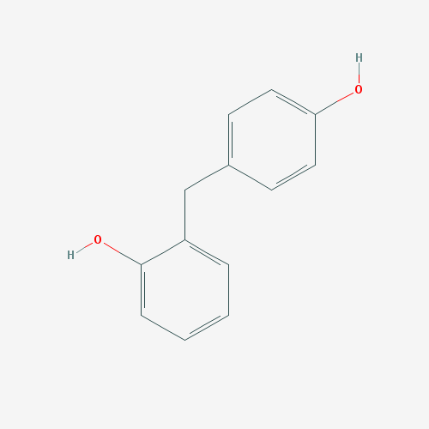
DM15 | Sodium picosulfate | 4,4'-dihydroxydiphenyl-(2 pyridyl)-methane
RXN-624 | 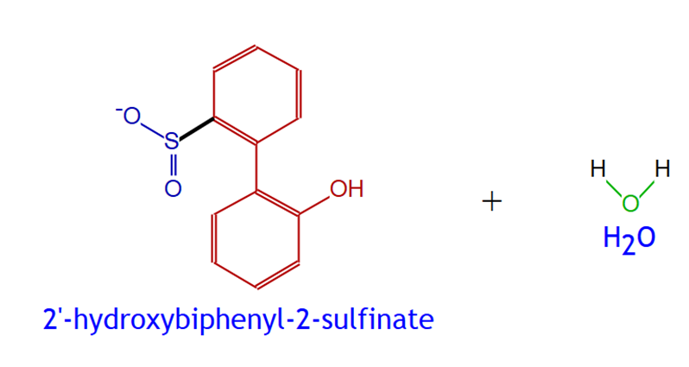 | 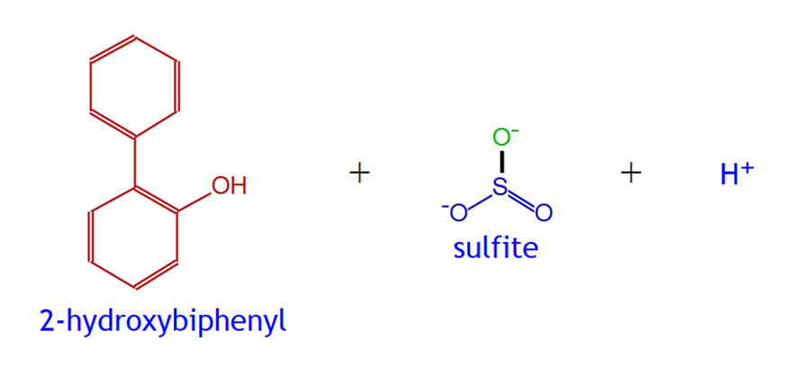
RXN-624 | 2'-hydroxybiphenyl-2-sulfinate | 2-hydroxybiphenyl
CHOLINE-SULFATASE-RXN | 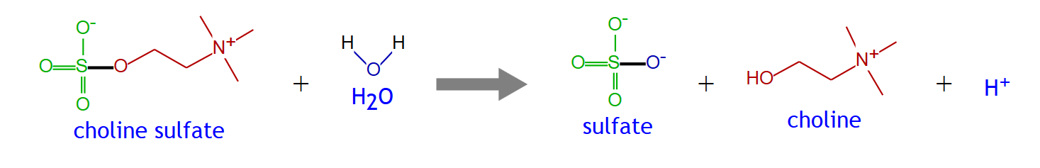
CHOLINE-SULFATASE-RXN | choline sulfate | choline
DM18 | 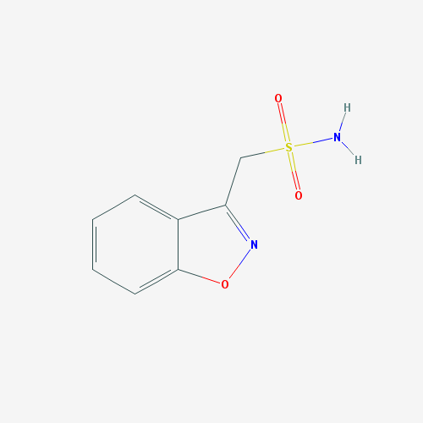 | 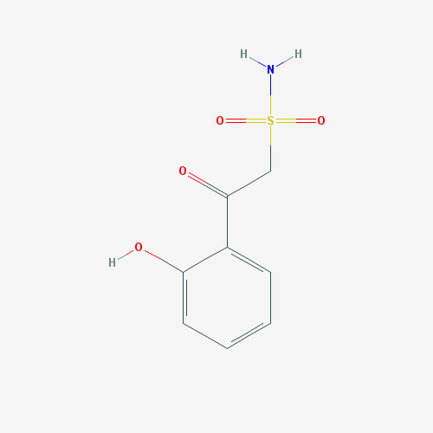
DM18 | Zonisamide | 2-Sulfamoylacetylphenol
RXN-14995 | 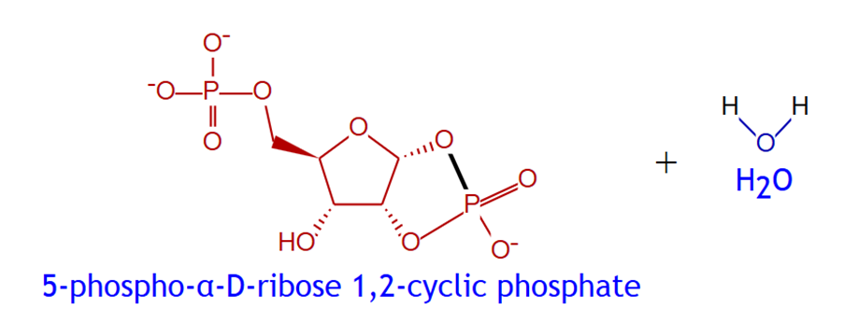 | 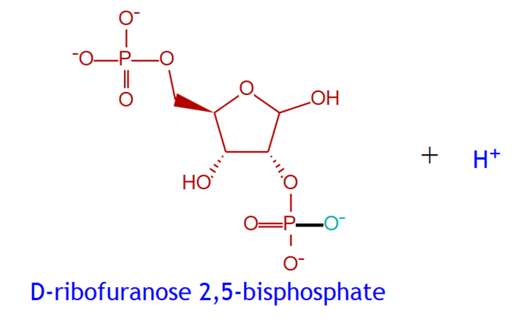
RXN-14995 | 5-phospho-alpha-D-ribose 1,2-cyclic phosphate | D-ribofuranose 2,5-bisphosphate
RXN0-6710 | 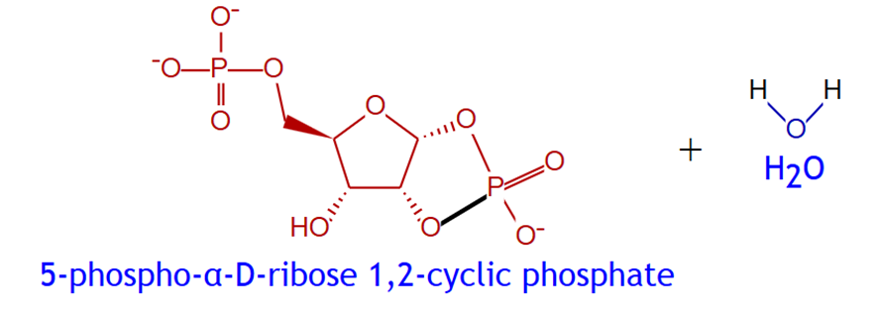 | 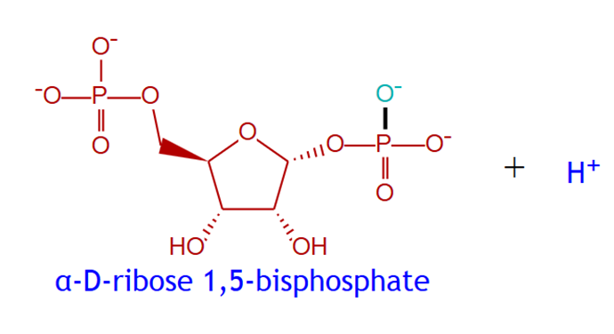
RXN0-6710 | 5-phospho-alpha-D-ribose 1,2-cyclic phosphate | alpha-D-ribose 1,5-bisphosphate
DM19
DM19 | Levodopa | m-hydroxyphenylacetic acid
RXN-10610 | 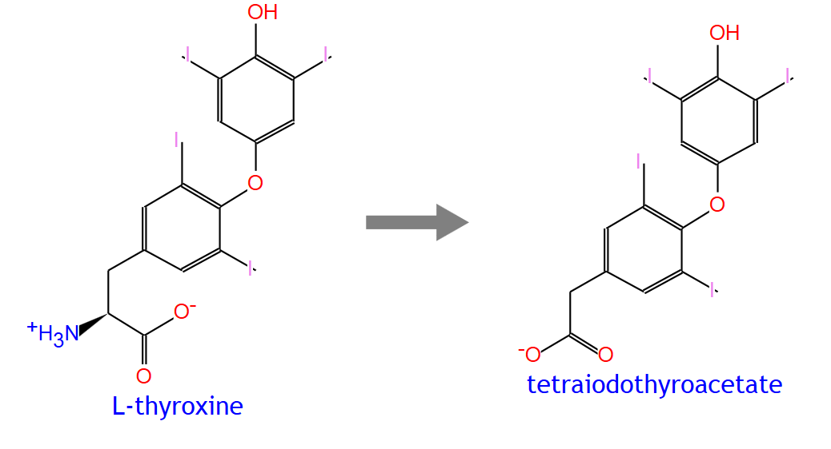
RXN-10610 | L-thyroxine | tetraiodothyroacetate
RXN-10611 | 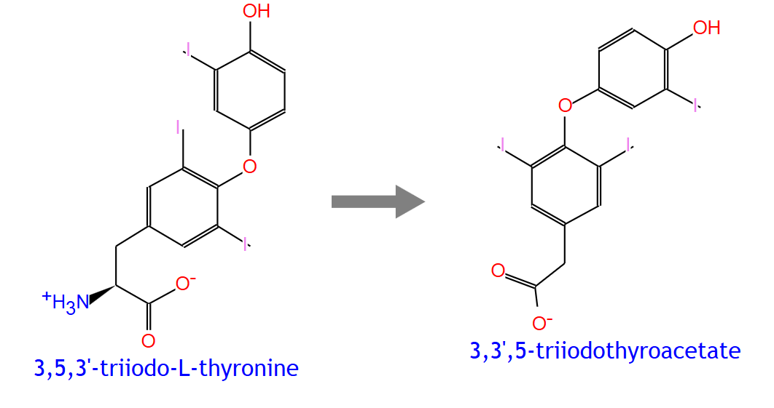
RXN-10611 | 3,5,3'-triiodo-L-thyronine | 3,3',5-triiodothyroacetate
DM1 | 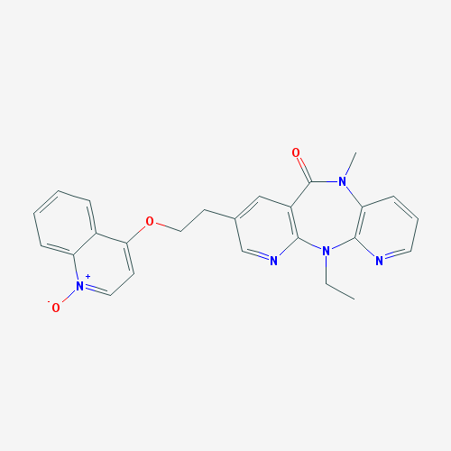 | 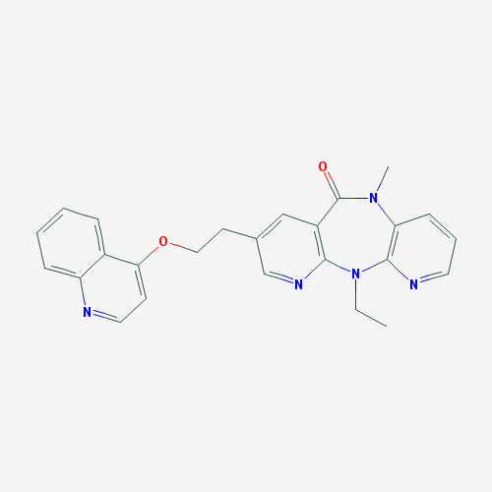
DM1 | BILR 355 | BILR 402
RXN-16233 | 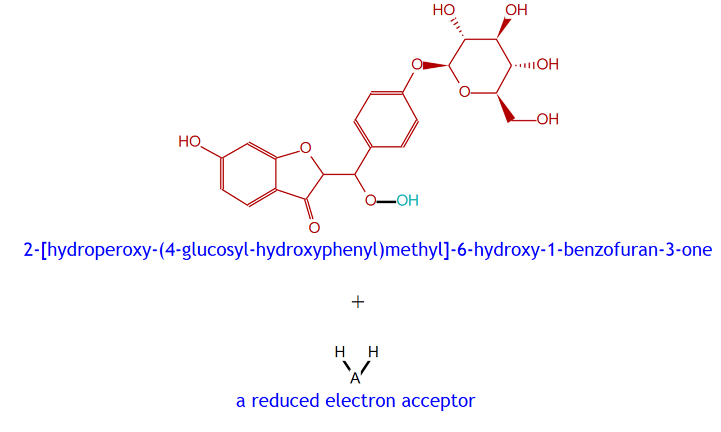 | 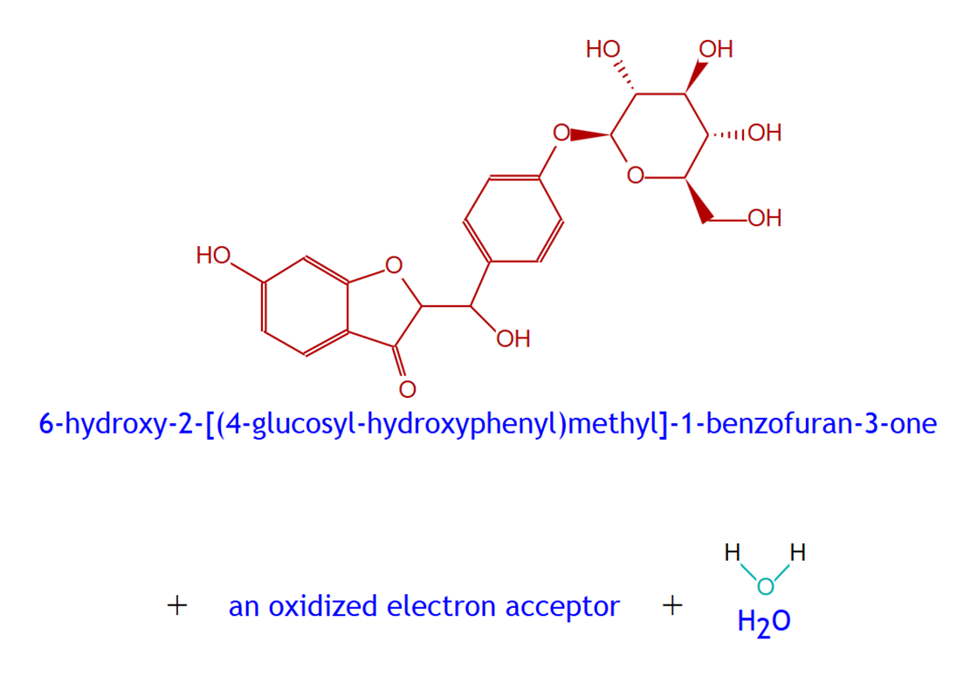
RXN-16233 | 2-[hydroperoxy-(4-glucosyl-hydroxyphenyl)methyl]-6-hydroxy-1-benzofuran-3-one | 6-hydroxy-2-[(4-glucosyl-hydroxyphenyl)methyl]-1-benzofuran-3-one
RXN-16871 | 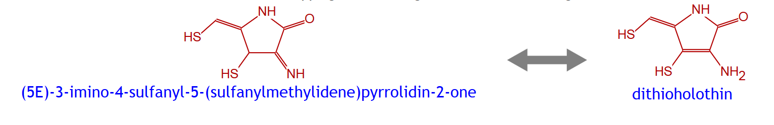
RXN-16871 | (5E)-3-imino-4-sulfanyl-5-(sulfanylmethylidene)pyrrolidin-2-one | dithioholothin
DM2 | 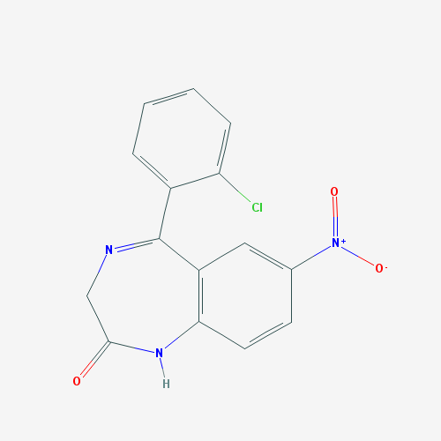 | 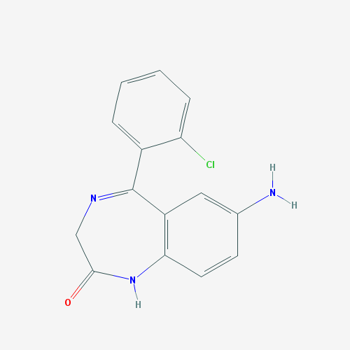
DM2 | Clonazepam | 7-aminoclonazepam
RXN-8833 |  | 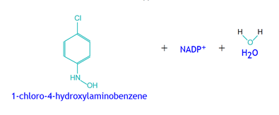
RXN-8833 | 1-chloro-4-nitrobenzene | 1-chloro-4-nitrosobenzene
RXN-12130
RXN-12130 | nitrous oxide | N₂
DM3 | 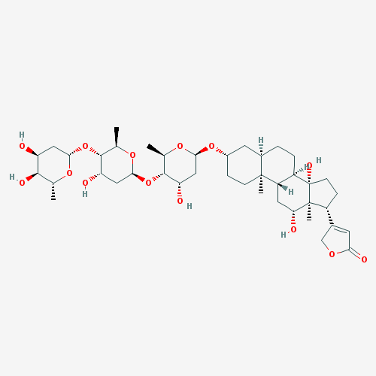 | 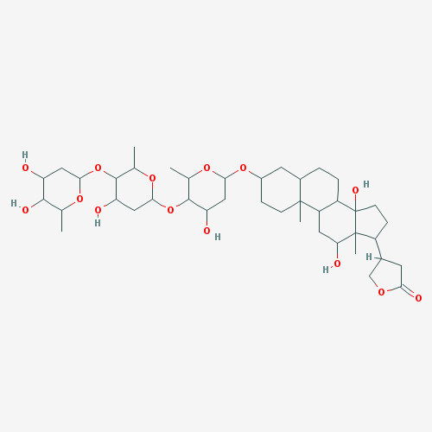
DM3 | Digoxin | dihydrodigoxin
RXN-13384 | 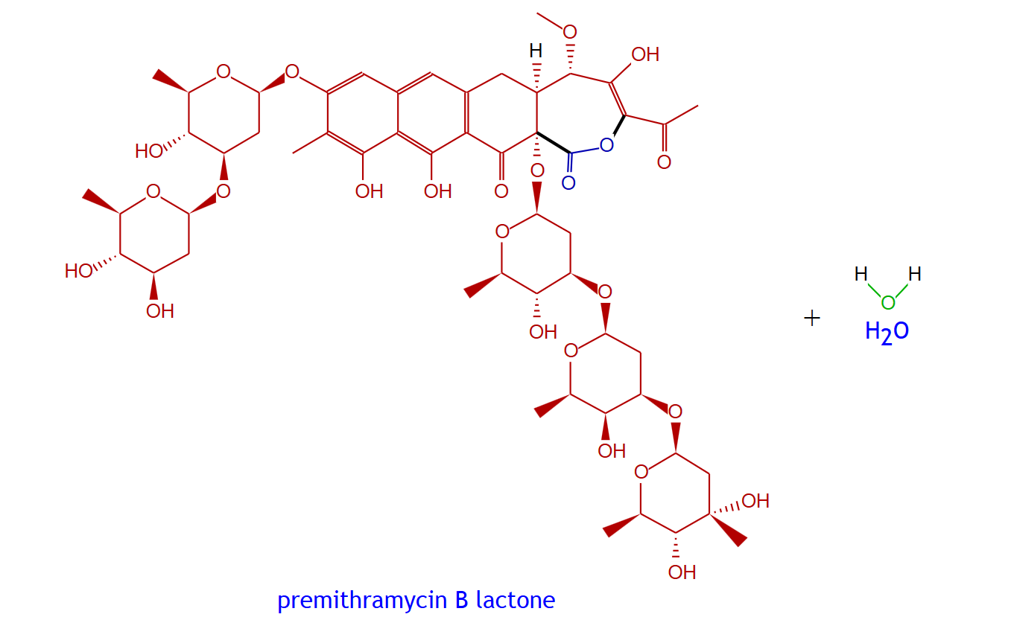 | 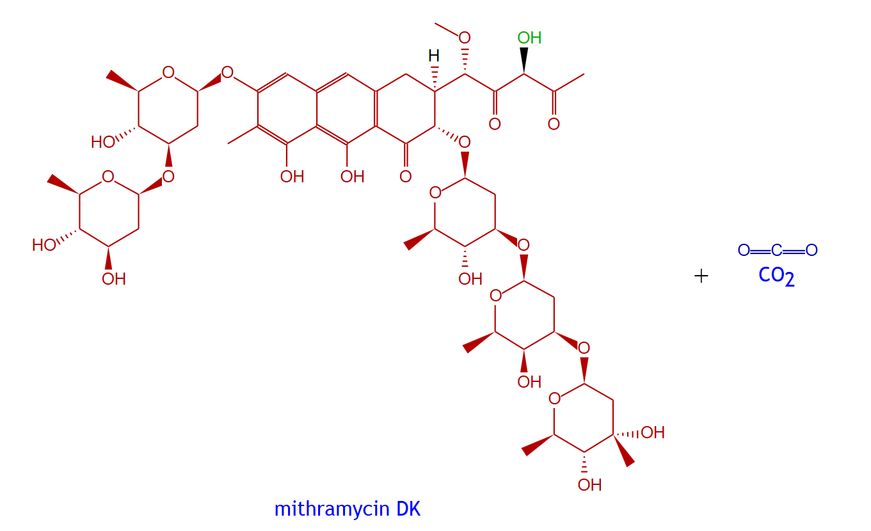
RXN-13384 | premithramycin B lactone | mithramycin DK
RXN-9794 | 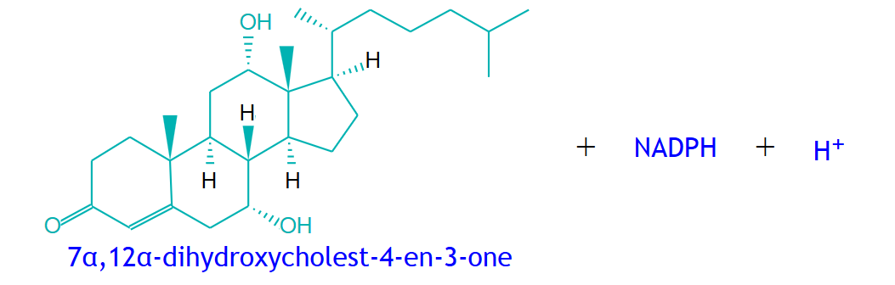 | 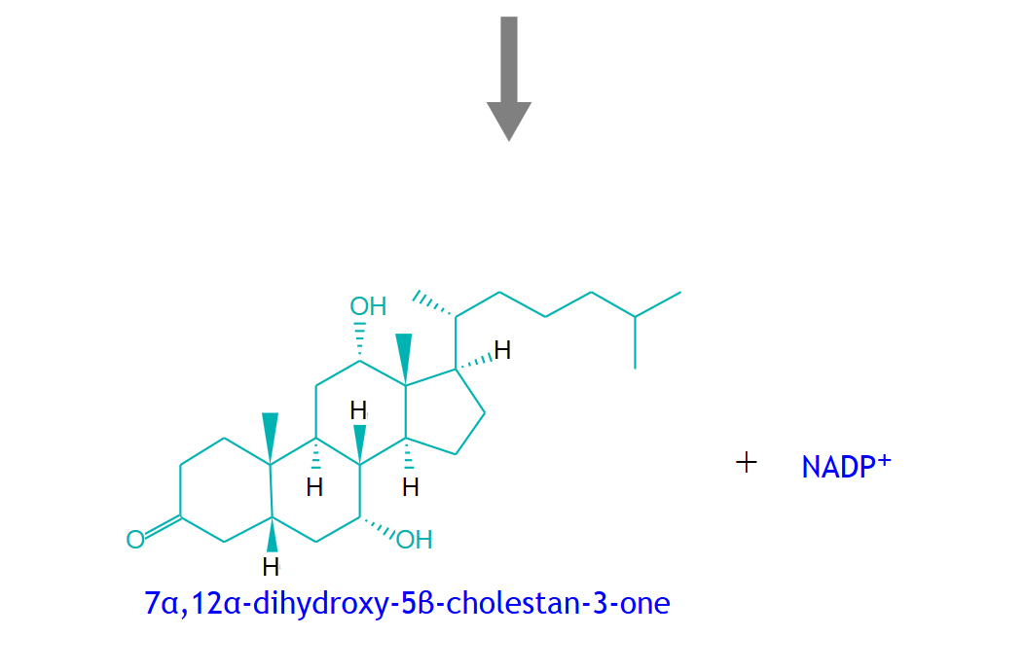
RXN-9794 | 7alpha,12alpha-dihydroxycholest-4-en-3-one | 7alpha,12alpha-dihydroxy-5beta-cholestan-3-one
DM4 | 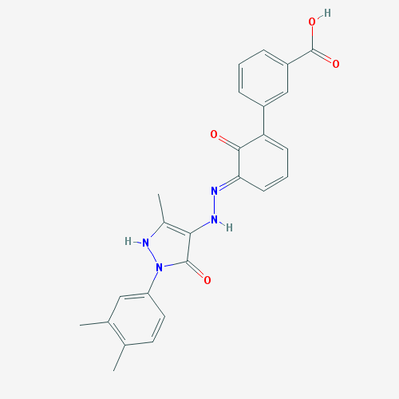 | 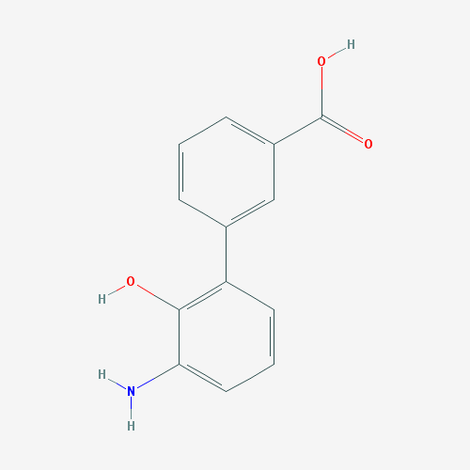
DM4 | Eltrombopag | SB-611855
RXN-8846 | 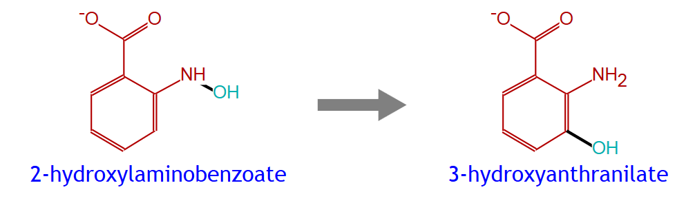
RXN-8846 | 2-hydroxylaminobenzoate | 3-hydroxyanthranilate
RXN-15187 | 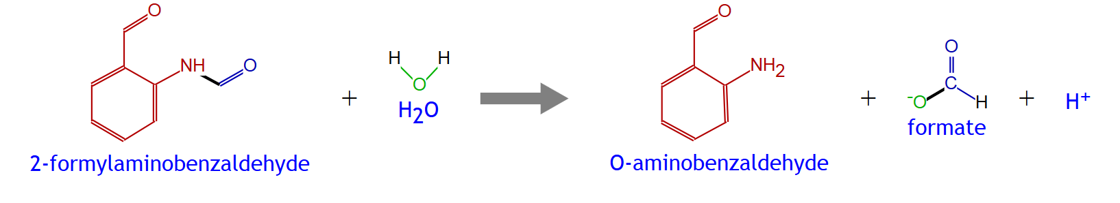
RXN-15187 | 2-formylaminobenzaldehyde | O-aminobenzaldehyde
DM5 | 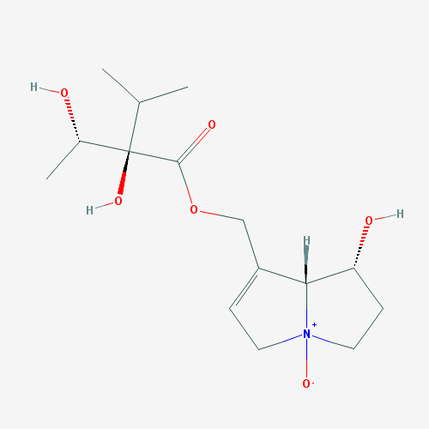 | 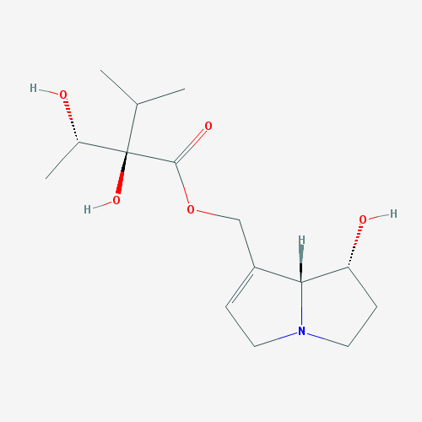
DM5 | Indicine N-oxide | Indicine
RXN-16233
RXN-16233 | 2-[hydroperoxy-(4-glucosyl-hydroxyphenyl)methyl]-6-hydroxy-1-benzofuran-3-one | 6-hydroxy-2-[(4-glucosyl-hydroxyphenyl)methyl]-1-benzofuran-3-one
RXN-16871
RXN-16871 | (5E)-3-imino-4-sulfanyl-5-(sulfanylmethylidene)pyrrolidin-2-one | dithioholothin
DM6 | 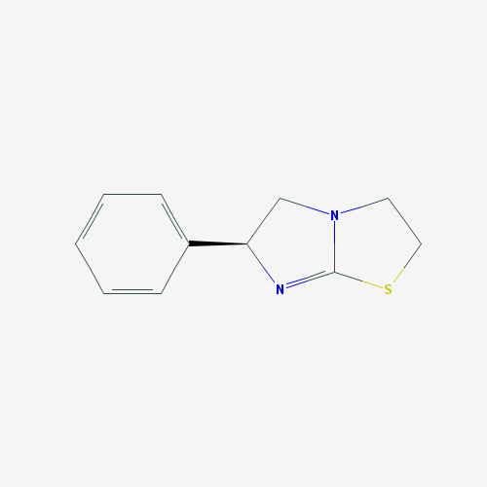 | 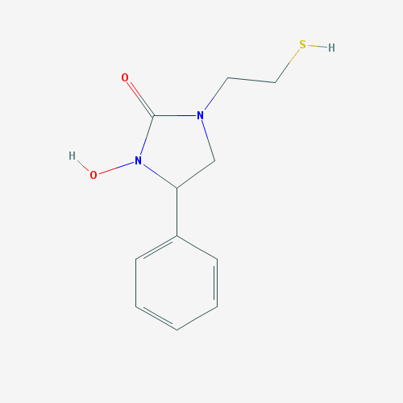
DM6 | Levamisole | Levametabol I
RXN-16141 | 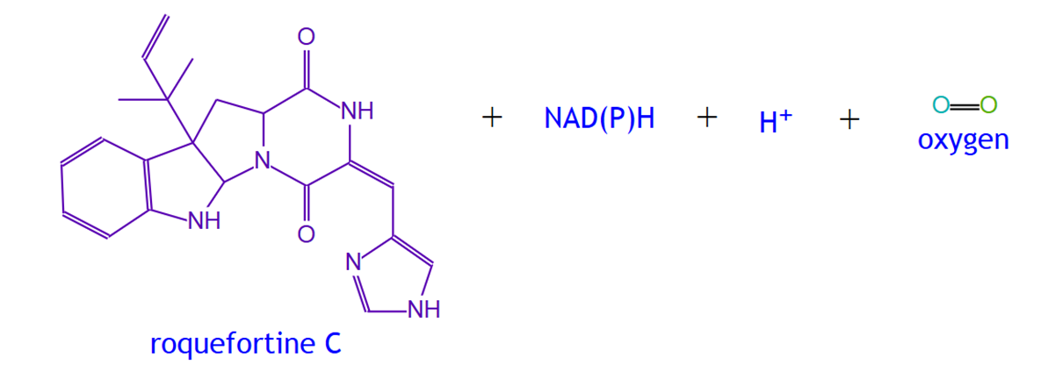 | 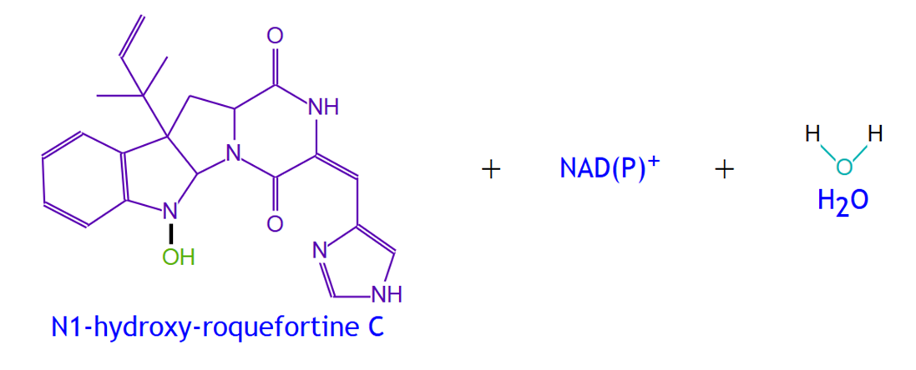
RXN-16141 | roquefortine C | N1-hydroxy-roquefortine C
RXN-16144 | 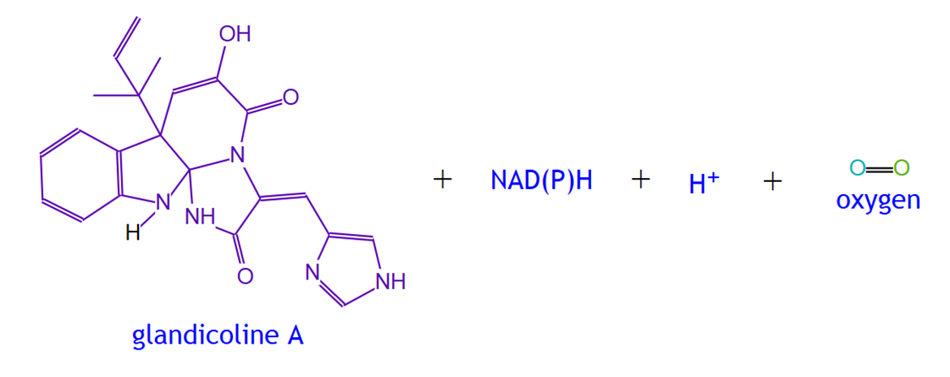 | 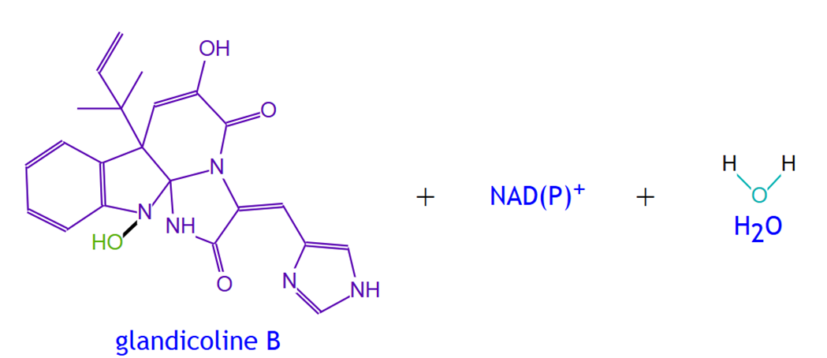
RXN-16144 | glandicoline A | glandicoline B
DM7 | 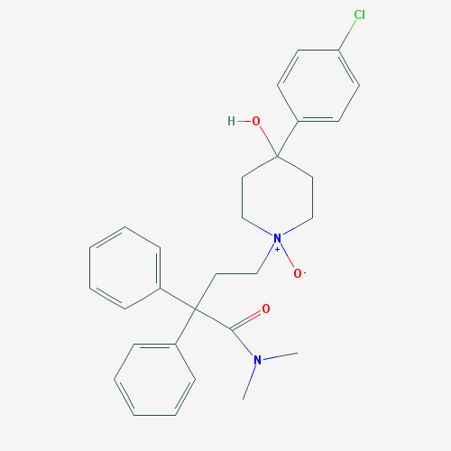 | 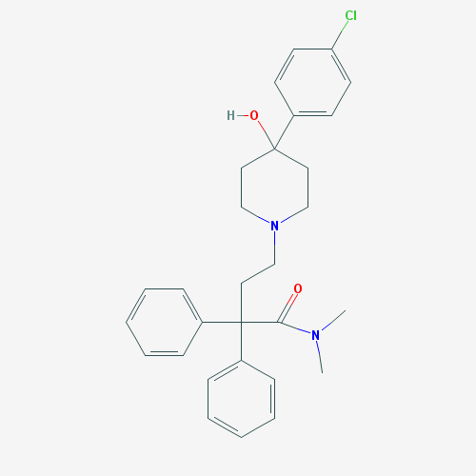
DM7 | Loperamide N-oxide | loperamide
RXN-16233
RXN-16233 | 2-[hydroperoxy-(4-glucosyl-hydroxyphenyl)methyl]-6-hydroxy-1-benzofuran-3-one | 6-hydroxy-2-[(4-glucosyl-hydroxyphenyl)methyl]-1-benzofuran-3-one
RXN-16871
RXN-16871 | (5E)-3-imino-4-sulfanyl-5-(sulfanylmethylidene)pyrrolidin-2-one | dithioholothin
DM8 | 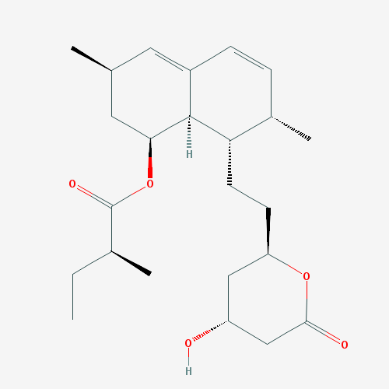 | 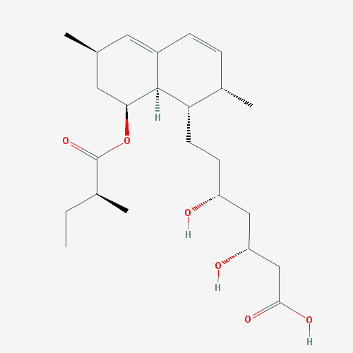
DM8 | Lovastatin | lovastatin acid
RXN-886 | 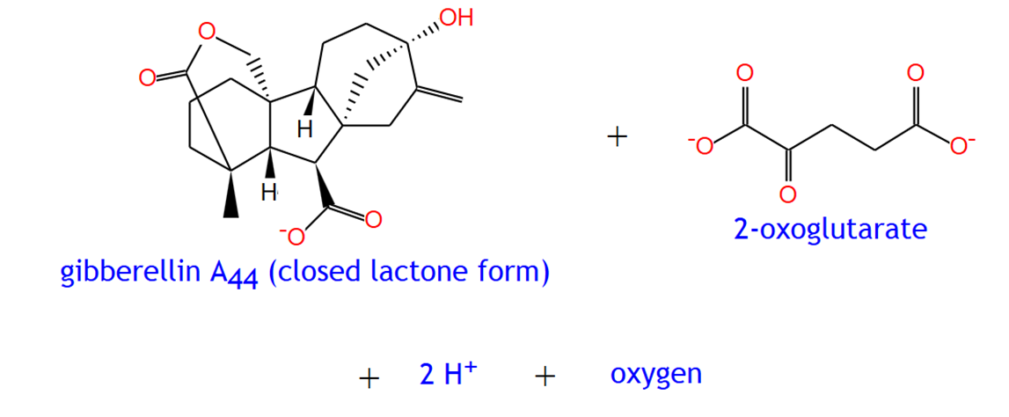 | 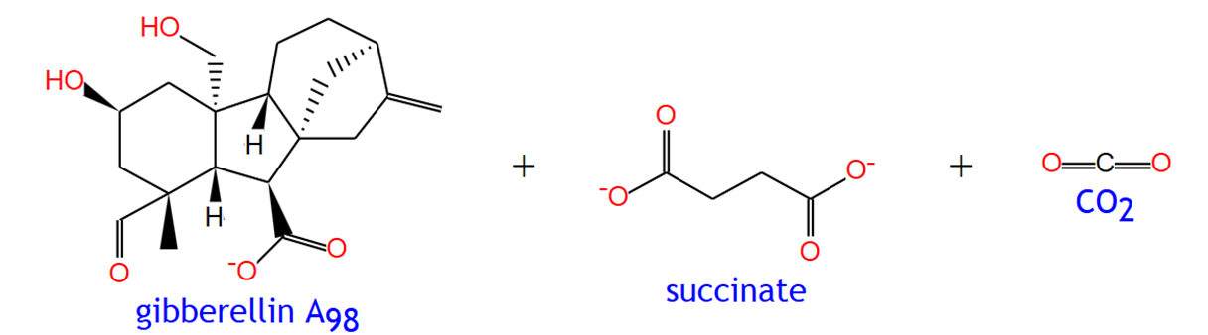
RXN-886 | gibberellin A₄₄ (closed lactone form) | gibberellin A₉₈
RXN1F-166 | 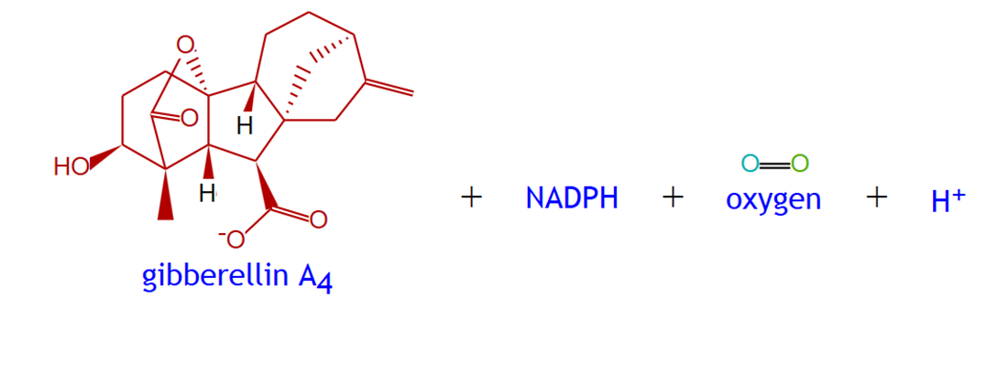 | 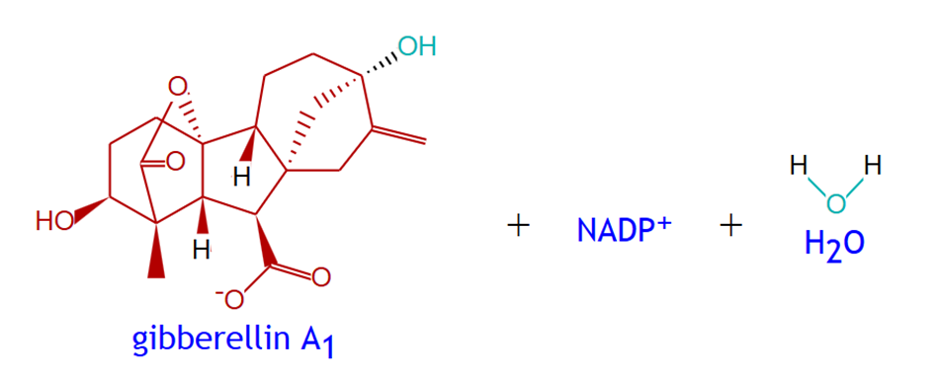
RXN1F-166 | gibberellin A₄ | gibberellin A₁
DM9 | 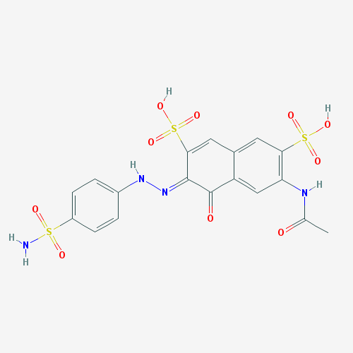
DM9 | Neoprontosil | sulphanilamide
RXN-14546 | 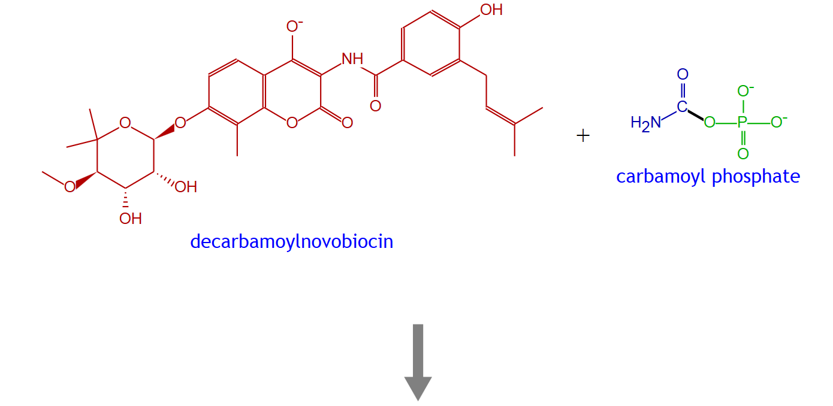 | 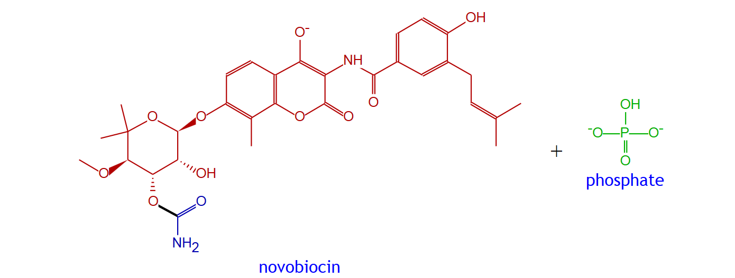
RXN-14546 | decarbamoylnovobiocin | novobiocin
RXN-15641 | 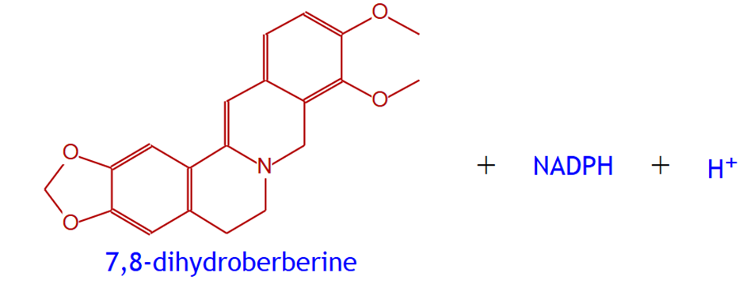 | 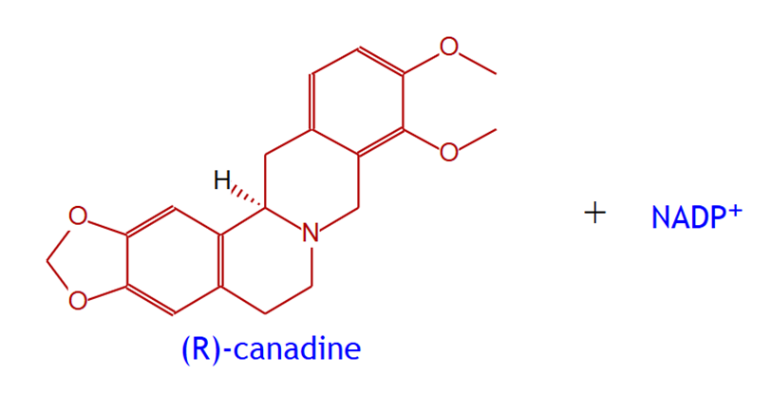
RXN-15641 | 7,8-dihydroberberine | (R)-canadine

National Center for Biotechnology Information. The PubChem Project. https://pubchem.ncbi.nlm.nih.gov/. National Library of Medicine, National Institutes of Health, Department of Health and Human Services, USA. (2017).
SRI International. MetaCyc Metabolic Pathway Database. https://metacyc.org/. Menlo Park, CA, USA. (2016).

