Rotating Book Plots
Lab 2: 2.4

The quantities that I guess would remain constant are: |H| & K

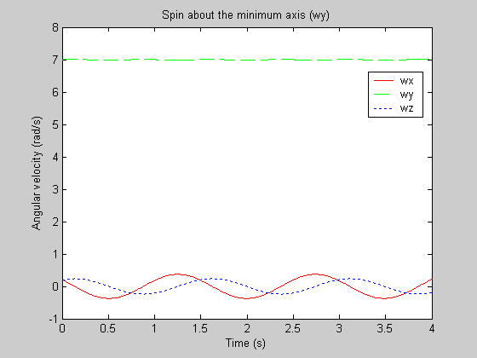
Spin about the minimum axis is neutrally stable.

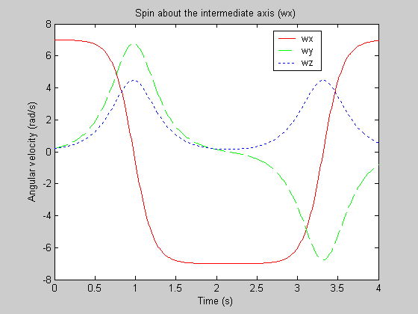
Spin about the intermediate axis is unstable.

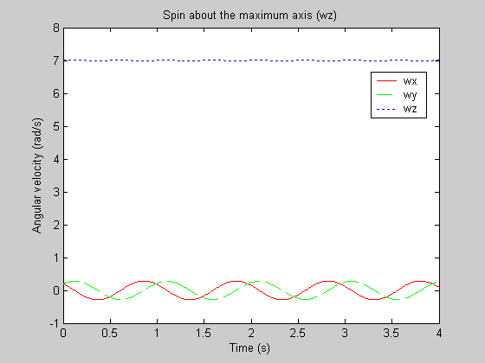
Spin about the maximum axis is neutrally stable.

The quantities that actually remain constant are: |H| & K

