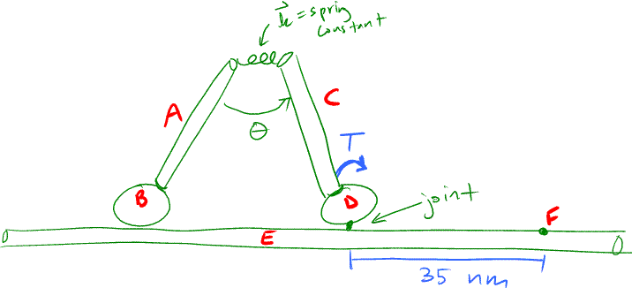
Schematic:

System description:
This is a very basic model for a Myosin V molecular motor. I am modeling it as a rod (A) attached rigidly to a sphere (B). This rod-sphere combination is attached to an identical copy of itself (C-D) by a 3D spring whose spring coefficient is also a function of the angle between A and C. This system is attached by a joint at sphere D to another rod, E, which represents the actin filament. The system will be started in the configuration shown. A torque is exerted at point D for a finite amount of time so the myosin takes one step.

Modeling considerations:
-The bodies are rigid
-The joints are frictionless
-The earth is a Newtonian reference frame.
- Gravitational forces are irrelevant
-Other forces such electromagnetic forces are irrelevant
-Viscous forces will first be assumed to be irrelevant, but may be added in later (see below)
-The joint at point D has a finite strength, which will be estimated from the force it takes in an optical trap to pull myosin off of an actin filament.
-The spring joining A and C cannot be broken.
-The energy imparted by the torque is about the same as the energy gained from hydrolysis of one ATP.
-The mass of each rod and sphere will be estimated from the structure/sequence of myosin V.

Proposed question:
A torque (T) will be exerted at sphere D to rotate rod C (and with it A-B) for a finite amount of time so that the myosin can take one step. My goal is to have B end up at point F, thereby taking a 35 nm step along the actin filament. I will tweak the spring constant and the torque to try to have B end up at F. I may also try to add in that B is attracted to point F, probably just as a force that is a delta function and applies when B is touching F. If I can get this to work, I’d also like to be able to add in viscous forces, which would assume laminar flow and assume that the cross sections of the rods don’t change significantly as the motor moves.

