Mary Williard Elting
BioE 215, Final Project
June 15, 2007
MIPSI Project Report: Modeling Stepping of Myosin V

Modeling Considerations
Summary of system
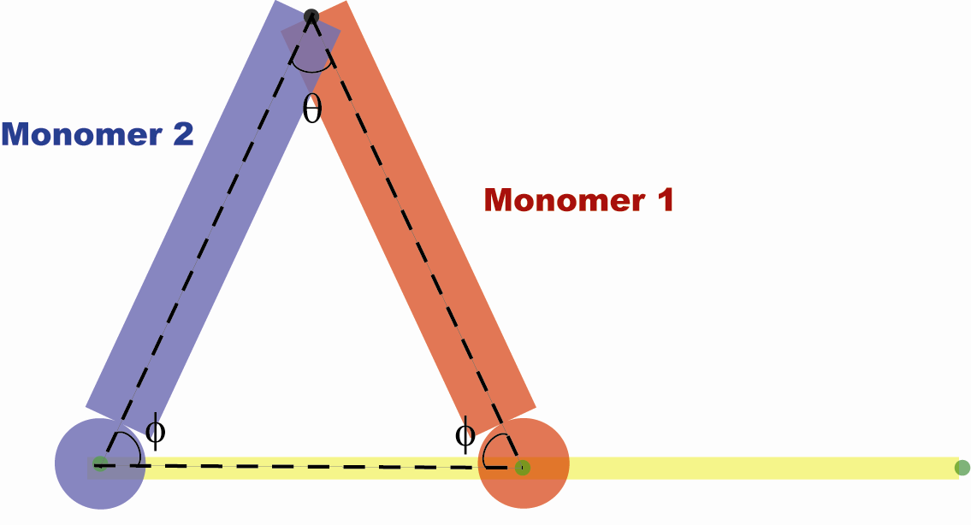
My project describes a very basic model of a single step of the Myosin V molecular motor. This molecule is made of two identical monomers joined at one end. I am modeling each monomer as a rigid rod (called the lever arm) attached rigidly to a rigid sphere (called the head). A pin joint attaches the two monomers at the ends of the arms. The monomer that begins as the “leading head” (monomer1, shown in red) is attached to the actin filament (shown in yellow, modeled by ground) by another pin joint. Monomer2 is shown in blue. Binding sites on the actin, spaced 36 nm apart, are shown in green. The system is initialized with the angles of the pin joints chosen so that each rod makes the same angle with the actin filament and the distance between the two heads is 36 nm. This means that the angle between the actin filament and arm1, φ, is 64.5º and the angle between the two arms, θ, is 51º. After initialization, a torque spring rotates monomer 1 about the pin joint with actin, and monomer 2 is carried forward by momentum. Monomer2 is attracted to the next binding site along actin. Viscous forces are also modeled as Stokes drag, as described below.

Mass details
As described above, each monomer is identical. The masses and dimensions of the monomers have been estimated from crystal structures and sequences as follows:
The mass and dimensions of the heads are estimated from the crystal structure of the Myosin V motor domain. The approximate diameter of the head, measured from the crystal structure, is 7.5 nm. The approximate mass of the head, based on the sequence of the Myosin V motor domain, which contains 766 amino acids, and an average mass of each amino acid as 0.110 kDaltons, gives a total mass of about 84.3 kD.
To estimate the mass and dimensions of the arm, the lever arm is considered as the myosin V lever arm structure with 6 calmodulins bound along the arm. From the crystal structure of calmodulin, its diameter is roughly 5.9 nm. Since there are 6 calmodulins bound along the lever arm, this gives a length for the lever arm of about 35 nm. The mass of the myosin V lever arm sequence contains 150 amino acids, and each calmodulin includes 148 amino acids, giving a total of 1038 amino acids and an approximate mass of the lever arm of 114.2 kD.

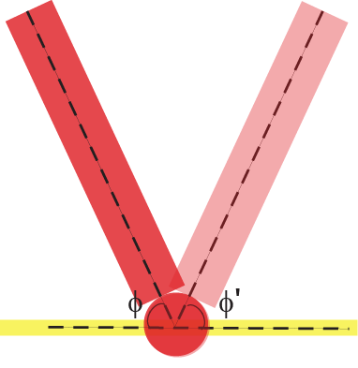
Because the actin is static in this model, it is not explicitly modeled. However, for visualization purposes, it is depicted as a cylinder with a radius of 5 nm, a good approximation for its actual radius. Binding sites are depicted as spheres 36 nm apart, the approximate length of the pseudo-repeat of actin.

Force details
Torque spring: A torque spring with damping rotates monomer1 clockwise. This represents what is usually called the “stroke” of the molecule. The natural angle of this torque spring, φ’, is equal to the original angle, φ, as shown at left. A very stiff spring with damping is probably a reasonable model for the conformational change that actually occurs in the motor domain when the molecule strokes. However, very little is known quantitatively about the forces involved in this conformational change. Therefore, it is very difficult to estimate actual values for the stiffness and damping coefficient in the spring. For this model, these constants were chosen so that the monomer quickly moved from one angle to another (i.e., the spring is fairly stiff) with a high enough level of damping that there is little oscillation after the initial rotation (i.e., close to critically damped).

An attractive force, with damping, attracts head2 to the next actin binding site, 36 nm from the binding site of head1. This force approximates the binding of head2 to its actin binding site. Again, this force is not easily estimated from experiment. It is probably made up of multiple Van der Waals interactions, but the way these superimpose is extremely complicated to predict. However, it is clear that this force should fall off quickly with distance, so I used a force that decays as 1/r⁶, where r is the distance of the head’s center from the binding site. Values for these coefficients of attraction and damping are chosen so that head2 is attracted to its binding site and stops there without overshooting the binding site. A maximum force is also added to prevent divide by 0 problems at very short distances.

Stokes drag viscous forces are also included on both heads. This means that the force is proportional to velocity, appropriate at the low Reynolds number of this system. To do this, each monomer is broken into 6 elements, and forces are applied proportional to the velocity and opposite to the direction of velocity of each of those elements. The proportionality constant, again not easy to calculate quantitatively from experiment, is estimated in order to help damp the motion of the beads.

Identifiers
As described above, only values for mass and dimensions are modeled from experimental values. The other values in this model are chosen to provide a reasonable-looking model, where the majority of the time is taken up by Monomer2 searching for a binding site, as probably occurs in the actual Myosin V step. Because these numbers are chosen to make a convenient-looking model, their units are not well-defined, although they are consistent throughout the model. The mass and distance measurements are defined as kD and nm, respectively, but the unit of time is not defined so the force coefficients are not either. However, since the entire stroke takes about 10 units of time in the model, between 100 ns and 1 ms is probably a reasonable approximation for the unit of time in this model, since it probably takes a few ms or less for the entire step to occur. (Exact stepping times are not known since they are beyond current limits of time resolution.)
Symbol in code | Description | Value
massOfHead1, massOfHead2 | The (identical) masses of heads 1 and 2, in kDaltons | 84.3
radiusOfHead | The radius of the head, in nm | 2.95
massOfArm1, massOfArm2 | The (identical) masses of arms 1 and 2, in kDaltons | 114.2
radiusOfArm | The radius of the lever arm, in nm | 3.75
radiusOfActin | The radius of the actin filament | 2.5
monomer1Angle | The angle that monomer 1 makes with the vertical, in radians | 0.483
torqueSpringK | Stiffness of the torque spring attached to monomer1, arbitrary units, chosen as described above | 1000000000
torqueSpringDamping | Proportionality coefficient for damping in the torque spring, arbitrary units, chosen as described above | 1000000
attractionCoeff | The proportionality coefficient for attraction of monomer2 to its actin binding site, arbitrary units, chosen as described above | 100000
maxAttractiveForce | The maximum force of attraction. This limit is put in to avoid divide by 0 problems at very small angles. | 300000
dampingCoeff | The proportionality coefficient for damping in the attractive force, chosen as described above. | 100000
stokesDragConstant | The proportionality coefficient between velocity and drag | 10000

Interpretation of Results

The following figures indicate some of the results of this simulation. Figures 1 and 2 show how the angles of the arms change with time. There are discontinuities in the measured angle from arm2 because it is calculated using the arctangent function, which returns values for angle between -π and π. This is easily corrected, as shown in Figure 2, by adding multiples of 2π to the angle when these discontinuities occur. It is clear from this graph that both monomer1 and monomer2 are slightly underdamped, since slight oscillations do occur after they reach their approximate steady state. To reach the approximate steady state takes about 0.75 units of time for monomer 1 and about 6 units of time for monomer2. The abrupt “elbow” in the arm2 angle curve occurs when the head gets close enough to its actin binding site that the attractive force has a significant impact. This behavior can also be seen in Figure 3, which shows the velocity of head2 and the angle arm2 makes with the vertical.
Figure 1 Shows the angles of the two arms as they change with time. Monomer1 clearly stabilizes much more quickly than monomer2. Discontinuities in arm2 are a result of computing the angle as arctan.
Figure 2 Same data as in Figure 1, corrected for the discontinuities in arm2 by adding shifts in the angle.
Figure 3 Velocity of head2 and angle of arm2. Around 6 seconds, arm2 stabilizes and velocity goes to zero.
Analysis
This seems to be a successful first model for the myosin V step, although there are many possible refinements. The model for mass distribution and dimensions contains pretty reasonable estimates for their actual values. Though the force model is approximate and the parameters in that model are extremely rough estimates, I am successful at modeling a single 36 nm step. In addition, most of the amount of time in this step is taken by monomer2 finding its binding site, as shown in Figures 1 and 2. Monomer1 undergoes its change in angle fairly quickly. This is probably accurate to what happens in the actual motor. Monomer2 must find its binding site by diffusion, which is a slow process compared to the conformational change occurring in monomer1 to rotate about its binding site.

Possible Future Improvements
The most obvious shortcoming of this model is that the diffusive search of monomer2 for its new binding site is replaced in the model by momentum that carries monomer2 forward. Because of the high Reynolds number of movement of water at this length scale, any momentum gained by an object is essentially instantly damped out by drag forces. Instead of momentum, monomer2 actually finds its binding site by a diffusive process. Eventually, head2 will be brought close enough to its binding site by diffusion that the attractive binding forces will take over. This means that the coefficient of Stokes drag used in my model should actually be much, much higher, and some way of modeling diffusion should be implemented into the model. However, modeling diffusion is a much more complicated process, and so I decided to allow momentum to carry monomer2 forward for this first pass at modeling Myosin V.

A second, less significant problem is that, as is apparent from all 3 figures, the motion of both arms is slightly underdamped. However, increasing the damping coefficients resulted in much longer simulation times, as they slowed down the movement of the masses, and longer computation times, as the computer had to deal with larger numbers. I therefore compromised in this model, and allowed slight underdamping simply to make the computation more practical.

