Cylinder A Calibration Device for Motion Analyst
Rev 01

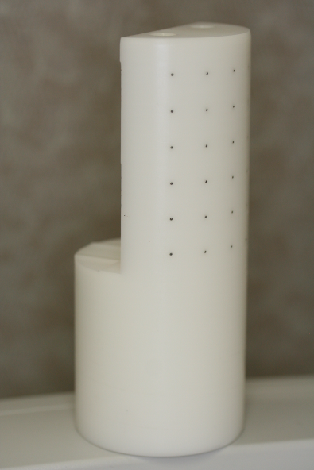
This device is the Cylinder A calibration device for 3D motion reconstruction using Motion Analyst. This device has more points than is required for the camera coefficients calibration and various regions can be used as appropriate. This document defines which points are which when it comes to performing the coefficients calculation.
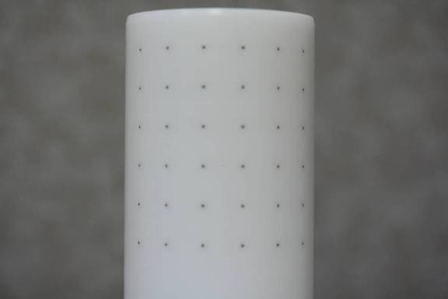
This is a picture of the device and all the calibration points. Select ones are shown to indicate the pattern used to label the points. Refer to the table below for the location and label for each.
1
6
36
311
7
x-axis
z-axis
y-axis
into page
Bead # position as you are facing the caibration grid.
Scan 020310- 45um
1 | 2 | 3 | 4 | 5 | 6
7 | 8 | 9 | 10 | 11 | 12
13 | 14 | 15 | 16 | 17 | 18
19 | 20 | 21 | 22 | 23 | 24
25 | 26 | 27 | 28 | 29 | 30
31 | 32 | 33 | 34 | 35 | 36

This device is a delrin rod with tantalum beads placed in small holes. The device was imaged using a micro CT and the corresponding x, y, z locations were derived. The coordinates were then transformed to the local coordinate system where the x axis was defined as a vector that started at the origin (point 1) and was directed through point 6 (right in above image). The z axis was defined as a vector that started at point 31 and was directed through the origin (point 1) (up in above image). The y axis is the complementary axis (pointed into the page in above image).
The following points were calculated for the positions relative to point 1 in the coordinate system defined above. The units are in mm.

Point | Scan 020310- 45um  Note that when doing coordinate transformations the vectors defined above are not guaranteed to be perpendicular. For this reason point 6 was only used as a temporary x axis and this is why the z value for point 6 is non-zero. It is more correct to say that points 1 and 31 define the z axis, points 1, 31, and 6 define the x-z plane, and the y axis is perpendicular to this plane.
Point | X | Y | Z
1 | 0.000 | 0.000 | 0.000
2 | 6.949 | -7.164 | -0.034
3 | 16.079 | -11.030 | -0.066
4 | 26.027 | -10.972 | -0.114
5 | 35.185 | -7.138 | -0.099
6 | 42.078 | 0.000 | -0.123
7 | -0.001 | -0.009 | -9.944
8 | 6.950 | -7.128 | -10.024
9 | 16.079 | -10.993 | -10.056
10 | 26.026 | -10.981 | -10.058
11 | 35.140 | -7.100 | -10.089
12 | 42.078 | -0.009 | -10.113
13 | -0.001 | -0.018 | -19.934
14 | 6.951 | -7.091 | -19.968
15 | 16.080 | -10.956 | -20.001
16 | 25.982 | -10.897 | -20.049
17 | 35.095 | -7.062 | -20.080
18 | 41.988 | 0.075 | -20.104
19 | 0.000 | 0.018 | -29.924
20 | 6.950 | -7.100 | -29.958
21 | 16.128 | -10.875 | -29.991
22 | 25.983 | -10.861 | -30.039
23 | 35.096 | -7.026 | -30.070
24 | 41.989 | 0.112 | -30.094
25 | 0.000 | 0.009 | -39.914
26 | 6.952 | -7.064 | -39.994
27 | 16.084 | -10.792 | -40.028
28 | 25.941 | -10.732 | -40.076
29 | 35.053 | -6.897 | -40.061
30 | 41.945 | 0.195 | -40.085
31 | 0.000 | 0.000 | -49.904
32 | 6.953 | -6.981 | -49.939
33 | 16.086 | -10.709 | -49.972
34 | 25.895 | -10.694 | -50.021
35 | 34.964 | -6.812 | -50.053
36 | 41.855 | 0.234 | -50.076

The following matlab code was used to perform the coordinate transformations and calibration file necessary for use of this device with the Motion Analyst software suite.

a = csvread('original pixel data.csv');
a = a*0.045823; % convert voxels to mm
origin = a(1,:);% use point 1 for origin
num = size(a);
for i=1:num(1)
a(i,:) = a(i,:) - origin; %remove offset from point 1
end

% establish origin and points used to define axes with offset data
origin = a(1,:);% use point 1
zpnt = a(31,:); % use point 31
xpnt = a(6,:); % use point 6

zaxis = origin - zpnt; % vector from pnt 31 to pnt 1
xaxis = xpnt - origin; % vector from pnt 31 to pnt 1

znorm = zaxis/norm(zaxis); %Normalize z vector
xtmpnorm = xaxis/norm(xaxis); %Normalize xtemp vector

yaxis = cross(znorm,xtmpnorm); % find y axis
ynorm = yaxis/norm(yaxis);%Normalize y vector

xaxis = cross(ynorm,znorm); % find x axis. since x and z may not have been perpindicular
xnorm = xaxis/norm(xaxis);%Normalize x vector. Just to be sure

R = [xnorm' ynorm' znorm']; % create rotation matrix
calpoints = (R'*a')'; % transform coordinates to localized CS

%gather information for file header
Name = input('What is the name of the person who created with file? ', 's');
device = input('What is the name of the device that was being calibrated? ', 's');

% create header file
CalFileHeader = {'Date/Time', datestr(now);
'Created By', Name;
'Calibration Device', device;
'Number of Points', num(1)};
% create units
units = 'mm';

% write calibration file
save('DevACalFile_full.mat', 'CalFileHeader', 'calpoints', 'units');

