Motion Analyst 3D Version 1.3 Help Documentation
Rev 1.3
Table of Contents
1 Revision History 1
2 Purpose 1
3 Using the Program 2
3.1 Getting Started 2
3.2 Select Data Files 3
3.3 Transform to 3D 4
3.4 Plot Residuals 4
3.5 Plot Controls 5
4 Files 6
4.1 Results3D.csv File 6
4.2 Results3D.mat File 6
5 Future Work 7
5.1 Known Bugs 7
5.2 Limitations 7

Revision History
Revision | Date | Name | Comment
01 | 2-10-10 | R. Colbrunn | Created
02 | 2-11-10 | R. Colbrunn | Updated to reflect version 1.2. Added ability to plot residuals.
1.3 | 5-13-12 | R. Colbrunn | Updated to reflect version 1.3. Made cross platform compatible (mac, unix). Fixed new bug with Matlab 2011 when opening files with 'versn' parameter.

Purpose
This document outlines how to use the Motion Analyst 3D software package (MotionAnalyst3D). It is built upon KineMat (written by Christoph Reinschmidt and Ton van den Bogert) which is a set of MATLAB function files written for the analysis of three-dimensional kinematics. KineMat is a SDK intended for intermediate to experienced MATLAB users. Motion Analyst provides a more user friendly GUI and automated functionality to employ the 3D Reconstruction capabilities of KineMat. Motion Analyst 3D is a software package that takes 2D motion data of markers from image sequences simultaneously captured by two cameras, applies a calibration coefficient matrix that defines the relative placement of the cameras in space, and reconstructs the motion of the markers in three dimensions.

Using the Program

Getting Started
This software is used to reconstruct 3D marker locations. To do this, the x, y locations of makers in 2D space must be tracked in time using MotionAnalyst2D. This also needs to be done using two cameras that simultaneously capture the images. The output of MotionAnalyst2D will be a Results2D.mat file for each camera. Then, the MotionAnalyst3D_cal program needs to be run to compute the calibration coefficients for the two cameras to calibrate how they are placed relative to each other in 3D space. By combining the two 2D files and the coefficients file, then 3D locations for those original markers can be reconstructed.

The program has 3 main areas: Select Data Files, Transform to 3D, and Plot Controls.
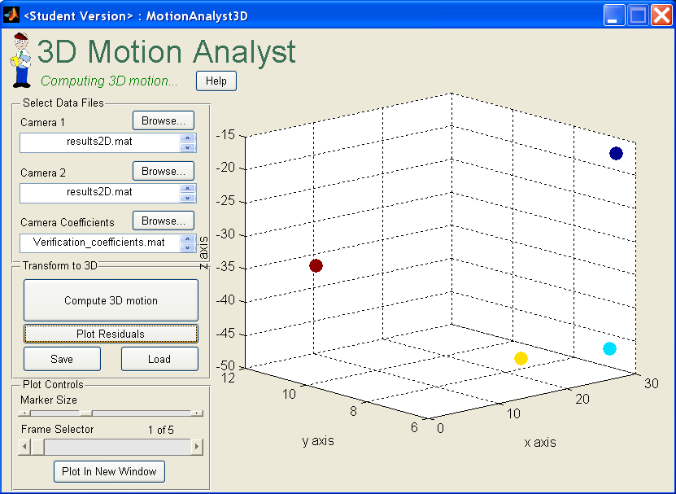

The program will reconstruct the 3D locations of the markers for each frame of the video (or more correctly image sequence). The program will save these locations as well as display the values on a 3D scatter plot to provide to easy verification of proper reconstruction.

Select Data Files
Start by pressing the browse buttons to select the resulting 2D motion tracking data from the first and second camera. Also select the appropriate camera coefficients file. It is important that the user is consistent in the definition of which camera is the first one and which one is the second when ordering these files and when having generated the coefficients file.
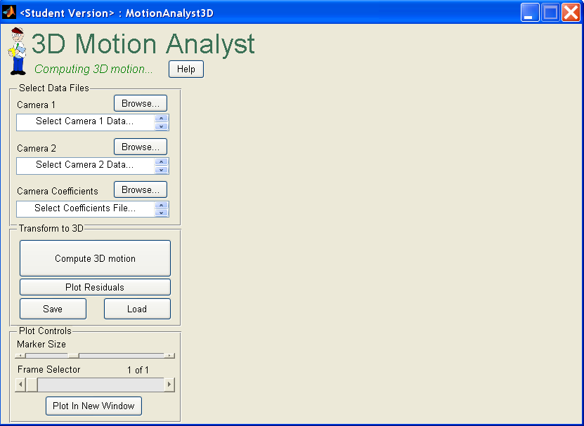

This will load the data and display the path to the file. The file name will be displayed and if the user holds the mouse over the file name the entire path to the file will appear.

Transform to 3D
Once the files are selected, click on Compute 3D motion and the user will be prompted to enter an output file name. The reconstructed maker locations will be saved to both a .mat file as well as a .csv file. See File section for more details.

By clicking the Save or Load buttons the Results3D.mat output file can be manually stored and loaded.

Note: If the ‘Compute 3D motion’ button has not been pressed the Save button will store empty values for the reconstructed points.

Plot Residuals
Imagine that if the two cameras were perfectly side by side and if the marker translated up 1mm in one camera and up 2mm in the other, there would be a disagreement that could be due to the 2D tracking algorithm, lens distortion, etc. This is the type of error that produces what is referred to as residue or residuals. Checking the residuals from the 3D reconstruction is a useful was to determine if the 2D tracking was well done, if the reconstruction was generally correct, if the wrong files were accidentally grabbed, if a camera was accidentally moved part of the way through the experiment, or many other reasons that could influence the accuracy of the reconstruction. In short, there are 4 degrees of information fed into the algorithm (x and y from each camera) and only 3 degrees out (x, y, z). The reduction in the degrees of freedom requires some optimization process and the residuals are a measure of how much disagreement between the redundant degrees of freedom there was. Clicking on the Plot Residuals button opens a new plot window and displays the residuals for each frame for each marker. Use this plot to look for outliers that could be the result of errors in the reconstruction. If all values generally look stable and low it is a good assumption that the reconstruction is well done.
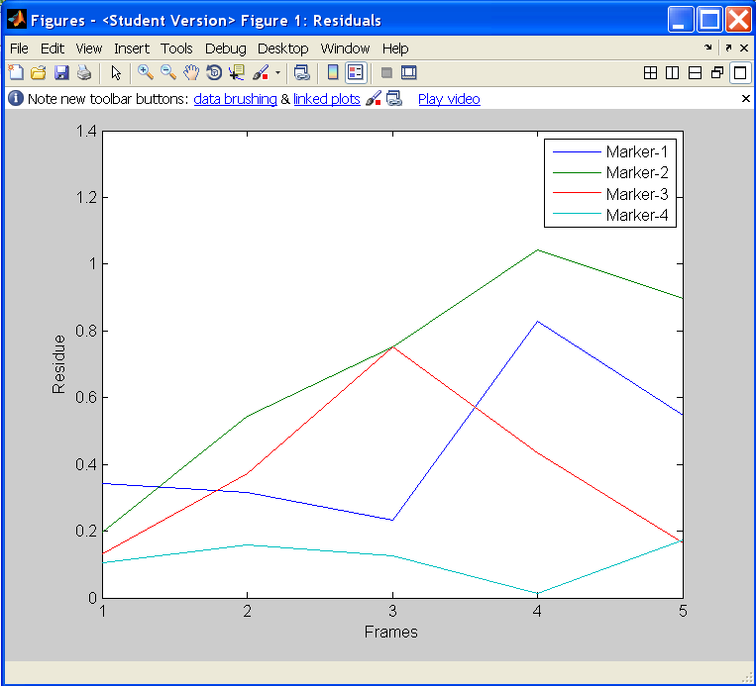

Plot Controls
The Plot Controls allow the user to modify the 3D scatterplot representation of the reconstructed points. The plot can be rotated by clicking a dragging on it. Marker Size makes the dots larger or smaller. Frame Selector allows the user to scan through all the frames in the image sequence and verify that the motion was as expected. The ‘Plot In New Window’ button loads the scatterplot, for that particular frame, into a Matlab figure so that all menu options exist for further data interrogation.

Files

Results3D.csv File
The 3D results.csv file is a comma separated value (.csv) file that, when imported into excel, looks like the following.
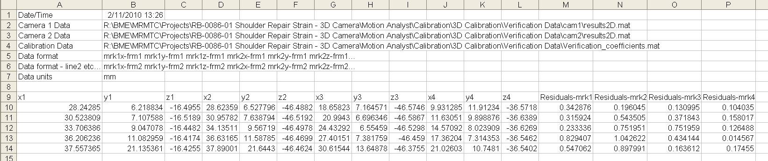

This file can be imported in any program to perform further processing the data. Note that the columns are for the x, y, and z values for each marker (including residuals) and the rows are the values for each subsequent frame in the image sequence.

Results3D.mat File
The 3D results.mat file is in a Matlab proprietary binary format with all the data organized in a way that manipulation in Motion Analyst can be easily completed. The three values contained in this file are ‘ResFile3DHeader’, ‘Data3D’, and “Residuals’. The ResFile3DHeader is a cell array, Data3D is a struct which contains a 2D array of points and frames for each axis x, y, and z, and the Residuals are for each frame and each marker. The 2D arrays are arranged per the description in the header where j correspond to the x, y, or z axis.
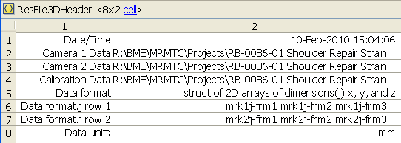

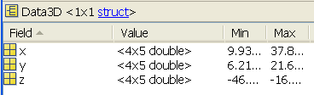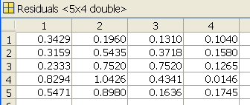

Future Work

Known Bugs
Error handling is limited and can be enhanced to improve functionality. For example, the files selected and loaded must be in the expected format to work.

Any error messages generated by the KineMat software will show up in the workspace and should be double checked if the program appears to hang up.

This is not necessarily a bug, but a reality when working with a Matlab GUI is that the current directory of the Matlab session needs to be directed to where the Motion Analyst files are located. If they are not, then when the user tries to click on any button the program will not respond until the current directory is returned to the correct location.

Limitations
KineMat can use more than 2 cameras, but this first version of Motion Analyst is limited to 2 cameras. Since our immediate need did not require functionality of more than two cameras it was not advantageous to make the code more flexible for multiples cameras. However, since this is open source, feel free to modify the code to suit your needs. It should also be mentioned that Motion Analyst only captures a subset of the KineMat functionality. There are many additional functions in KineMat that could be employed to enhance the value of Motion Analyst such as correcting for outliers and missing data points. Another known limitation is that there is no compensation for lens distortion. The 3D_cal program could add this functionality in the future. Algorithms for this are known and can be found in Biomechanics of the Musculo-skeletal System (Wiley 3rd edition) by Benno M. Nigg and Walter Herzog. This is also where the DLT algorithms can be found.

Motion Analyst has not been tested on all versions of Matlab Software. It must be run on Matlab revision 2008b or higher. It also requires the Image Processing toolbox.

