Motion Analyst Version 1.5 Help Documentation
Rev 1.5
Table of Contents
1 Revision History 1
2 Purpose 1
3 Using the Program 2
3.1 Getting Started 2
3.2 Version Numbering 3
4 Future Work 3
4.1 Known Bugs 3
4.2 Limitations 3

Revision History
Revision | Date | Name | Comment
01 | 2-10-10 | R. Colbrunn | Created
02 | 2-15-10 | R. Colbrunn | Updated section 4
03 | 3-24-11 | R. Colbrunn | Created Version 1.3 of software. Added new features to Motion Analyst 2D  Created section 3.2
04 | 11-17-11 | N. Mealey  R. Colbrunn | Created Version 1.4 of software. Improved robustness of Motion Analyst 2D
1.5 | 5-13-12 | R. Colbrunn | Created Version 1.5 of software. Made cross platform compatible (mac, unix). Improved robustness of Motion Analyst 2D and added image adjustment features.

Purpose
This document outlines how to use the Motion Analyst software suite. Motion Analyst is a software package to provide a suite of tools to determine 3D motion of markers from a series of still images using at least 2 cameras. It is built upon KineMat (written by Christoph Reinschmidt and Ton van den Bogert) which is a set of MATLAB function files written for the analysis of three-dimensional kinematics. KineMat is a SDK intended for intermediate to experienced MATLAB users. Motion Analyst provides a more user friendly GUI and automated functionality to employ the 3D Reconstruction capabilities of KineMat. In addition it provides an interface for the 2D texture correlation capabilities of the tc_multi_points.m software written by Michael Bey which can track the movement of markers in 2D images. This document is only a high level overview for the suite of tools. Each tool has its own documentation that should be consulted.

Using the Program

Getting Started
To start program open a Matlab session and run the MotionAnalyst.m file.

This software is used to reconstruct 3D marker locations. To do this, the x, y locations of makers in 2D space must be tracked in time using MotionAnalyst2D. This needs to be done using two cameras that simultaneously capture the images. After running MotionAnalyst2D for each camera the output will be individual Results2D.mat files for each camera. The MotionAnalyst3D_cal program needs to be run to compute the calibration coefficients for the two cameras to calibrate how they are placed relative to each other in 3D space. This is done by placing a device with markers of known spatial orientation in the field of view and taking a calibration image for each camera. By combining the two 2D files and the coefficients file, then 3D locations for those original markers can be reconstructed using MotionAnalyst3D. The reconstructed data will have units that match the units of the calibration device and will be in the same coordinate system that the known markers of the calibration device are in.
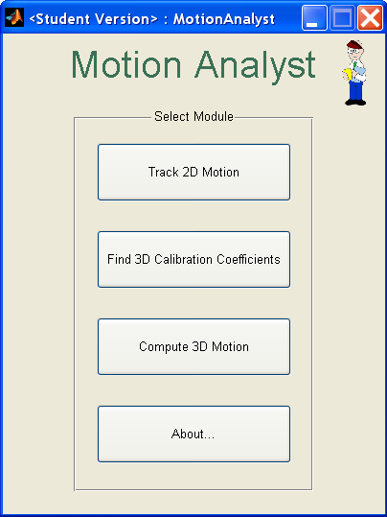

Version Numbering
Motion Analyst consists of three distinct software tools (2D, 3D cal, and 3D). Each tool has its own version numbering which may or may not be the same as another. Each tool is tested as a stand alone unit. Where cross-functionality has changed, testing will occur on all affected tools. The version of the main MotionAnalyst program will increment whenever a tool is changed. However, is a change is made to 2D, but none to 3D, the 2D version will change and the 3D version will remain the same. The following table contains the latest tested versions.

Software | Version
MotionAnalyst | 1.5
MotionAnalyst2D | 1.5
MotionAnalyst3D_cal | 1.3
MotionAnalyst3D | 1.3

Future Work

Known Bugs
See individual help files for each tool in the suite.

This is not necessarily a bug, but a reality when working with a Matlab GUI is that the current directory of the Matlab session needs to be directed to where the Motion Analyst files are located. If they are not, then when the user tries to click on any button the program will not respond until the current directory is returned to the correct location.

Limitations
KineMat can use more than 2 cameras, but this first version of Motion Analyst is limited to 2 cameras. Since our immediate need did not require functionality of more than two cameras it was not advantageous to make the code more flexible for multiples cameras. However, since this is open source, feel free to modify the code to suit your needs. It should also be mentioned that Motion Analyst only captures a subset of the KineMat functionality. There are many additional functions in KineMat that could be employed to enhance the value of Motion Analyst such as correcting for outliers and missing data points. Another known limitation is that there is no compensation for lens distortion. The 3D_cal program could add this functionality in the future. Algorithms for this are known and can be found in Biomechanics of the Musculo-skeletal System (Wiley 3rd edition) by Benno M. Nigg and Walter Herzog. This is also where the DLT algorithms can be found.

Motion Analyst has not been tested on all versions of Matlab Software. It must be run on Matlab revision 2008b or higher. It also requires the Image Processing toolbox.

